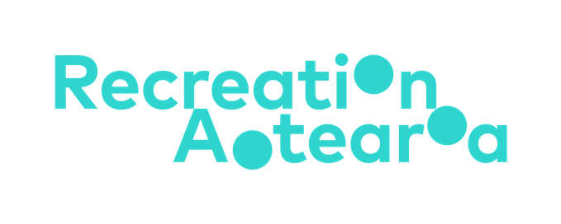



Summary:

Accessibility and inclusion in outdoor education and recreation
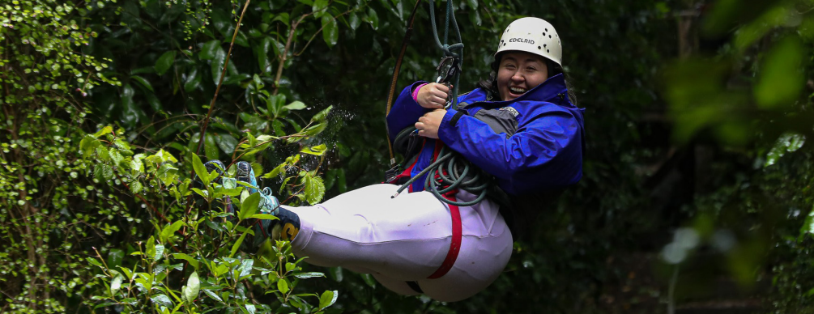
Image source: Halberg Foundation

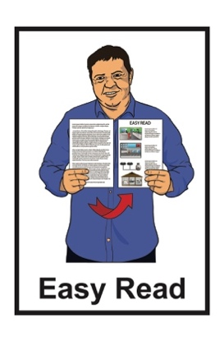

Published: April 2025

What you will find in here

Page number:

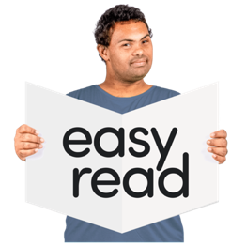
What this Easy Read is about 2

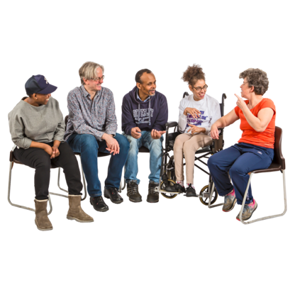
What is the guide about? 7

What the guide includes 12

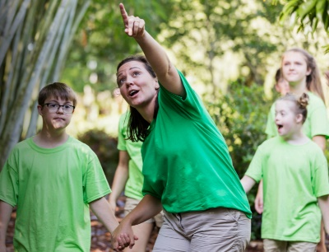
Extra information for outdoor
providers 23


Extra information for schools /
educators 29

Where to find more information 32

What this Easy Read is about

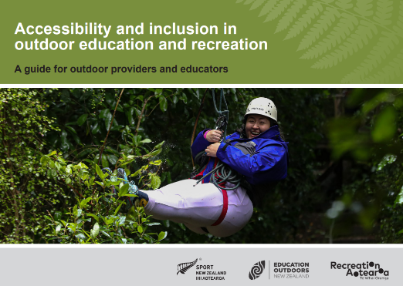
This Easy Read is a summary of a longer document called:
Accessibility and inclusion in outdoor education and recreation: A guide for outdoor providers and educators.
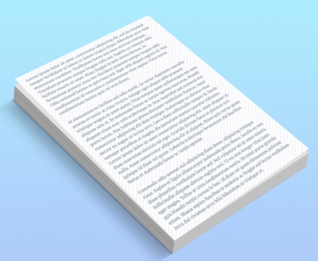

We will call the longer document the guide.


A summary:
is shorter than the full document
says the main points.


The guide is by:
Sport New Zealand Ihi Aotearoa
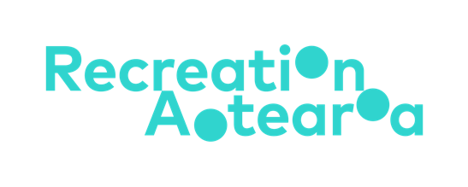

Education Outdoors New Zealand
Recreation Aotearoa.


You can find the guide on this website:

sportnz.org.nz/resources/accessibility-and-inclusion-in-the-outdoors
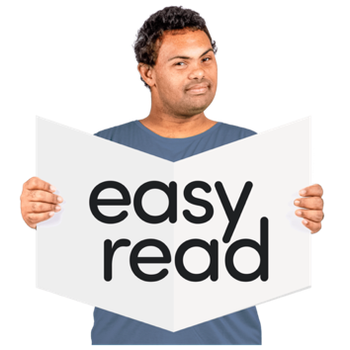

This Easy Read summary document tells you what you can find in the guide.

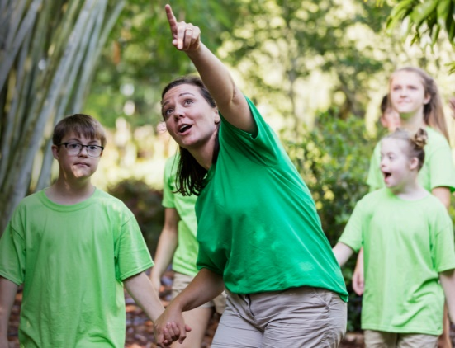
The guide is about outdoor activities like:
outdoor education
outdoor recreation.
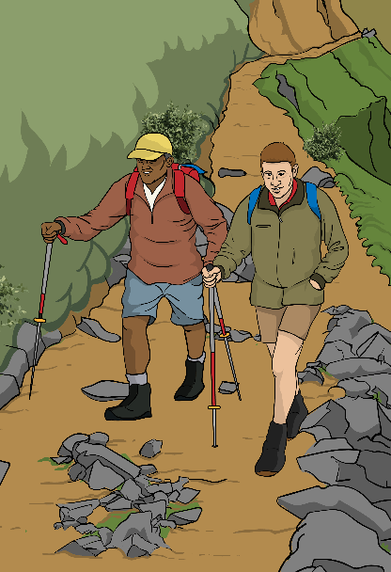

Outdoor education is learning new activities / skills in the outdoors.

Outdoor recreation is spending time doing outdoor activities to:
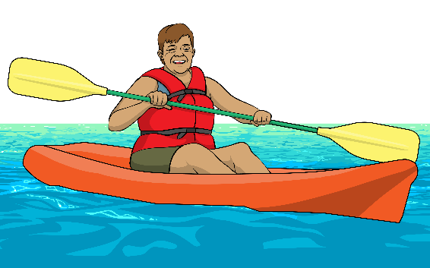
have fun
be active
enjoy nature.

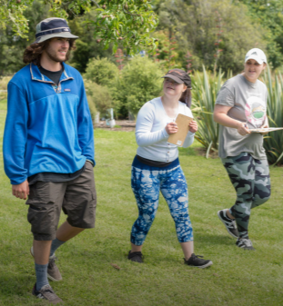
The guide is for:
outdoor providers
outdoor educators.
Image source:
Whenua Iti Outdoors

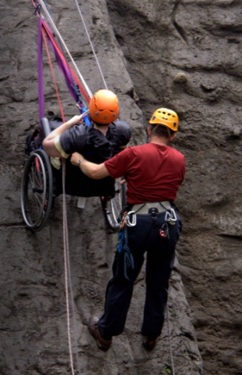
Outdoor providers offer programmes / activities for people to do things like:
hiking
rock climbing
Image source:
First Step Outdoors
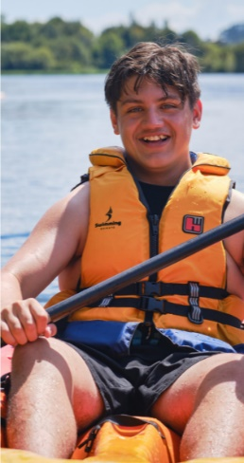
sailing
kayaking.

Image source:
Parafed Waikato
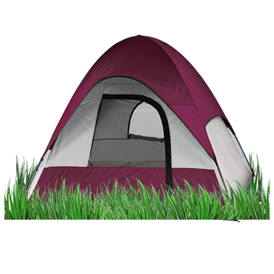
Outdoor educators are people who teach students outside the classroom like on a:
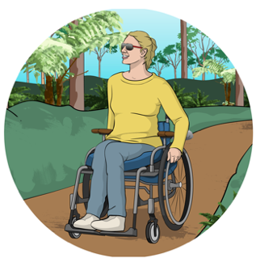
camping trip
recreation activity
nature visit.
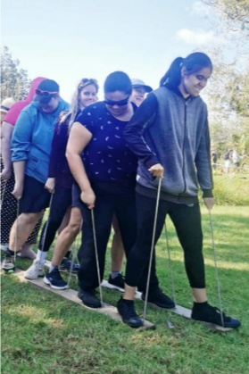

They teach skills like:
team work
confidence
leadership.
Image source:
Blind Sport NZ
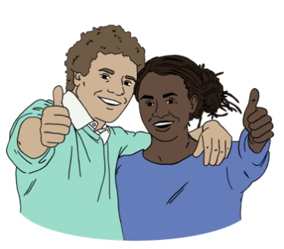

Confidence means being sure of your ability to do things your way.

What is the guide about?

The guide is about making sure everyone in Aotearoa New Zealand can access outdoor activities.

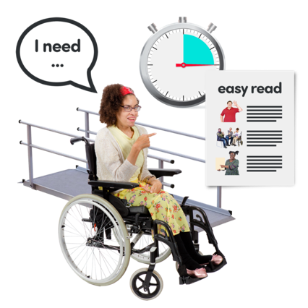
Access means you can:
get to a service
use the service.

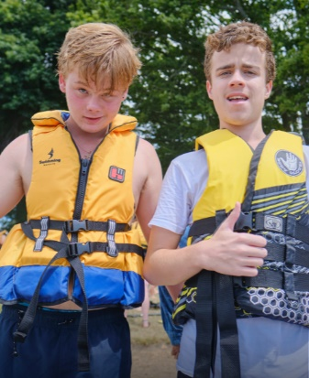
In Aotearoa New Zealand outdoor activities should be available for all:
tamariki / children
rangatahi / young people.
Image source:
Parafed Waikato

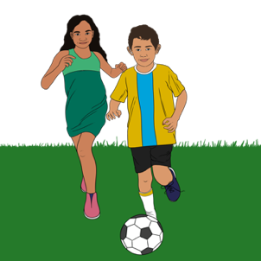
Tamariki / children and rangatahi / young people should be able to access outdoor activities no matter their:
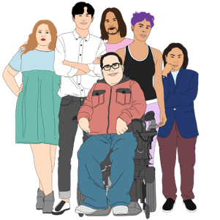
age
gender which is whether they are:
- a man
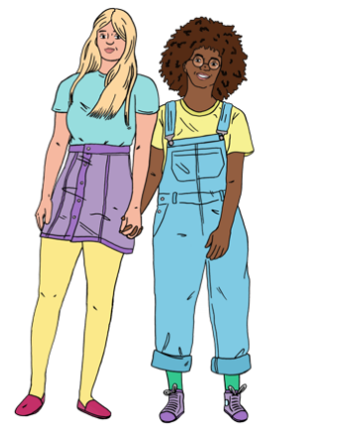
- a woman
- another gender like non-binary
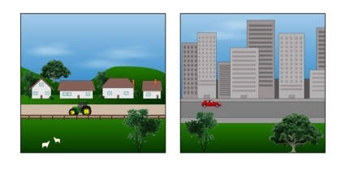
sexual orientation which is who they are attracted to
place where they live.

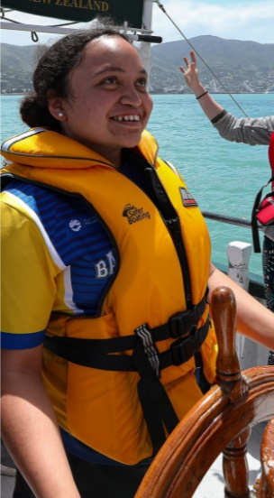
Tamariki / children and rangatahi / young people should also be able to access outdoor activities no matter their:
ethnicity
ability / what they can do.
Image source:
Halberg Foundation

Ethnicity means what culture you are part of like:
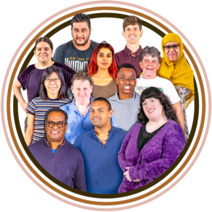
- Māori
- Pasifka
- New Zealand European / Pākeha
- Chinese

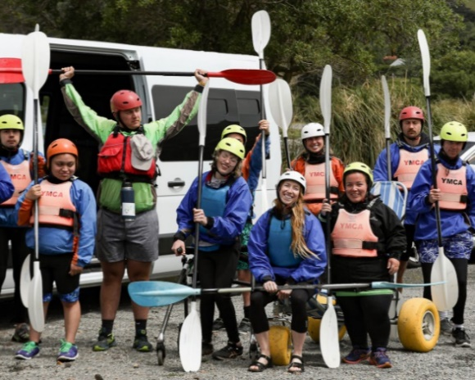
Outdoor providers / educators in Aotearoa New Zealand should think about:
accessibility which is making sure everyone has a way to do the outdoor activity
Image source:
Halberg Foundation
inclusion which means everyone feels welcome to do the outdoor activity.
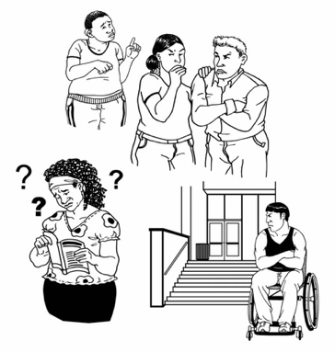

This is to remove barriers to access which are the things that stop some people from being able to take part.

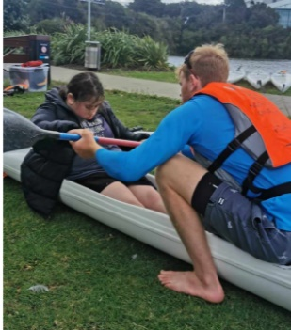
Removing barriers allows disabled tamariki / rangatahi to take part in outdoor activities.
Image source:
Blind Sport NZ

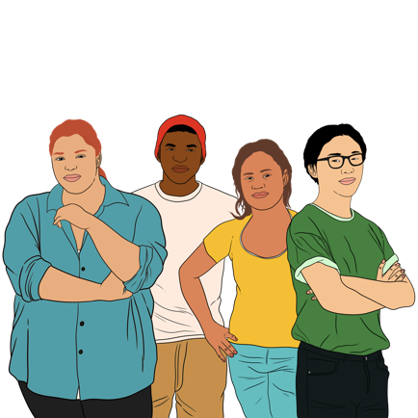
1 in 4 New Zealanders are disabled.

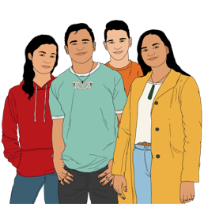
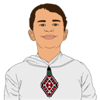
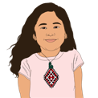
About 1 in 10 people less than
15 years old are disabled.

The guide teaches people to:
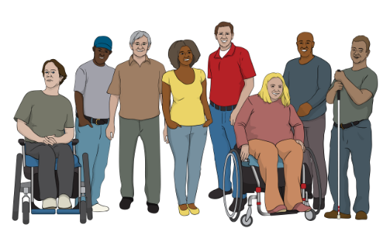
see the barriers to access as the problem
not see the ways people are disabled as the problem
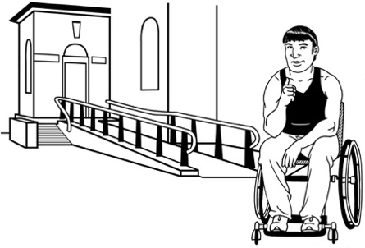
remove barriers so that disabled people can access outdoor activities.

What the guide includes

The guide includes the following information.

Words to use about disability
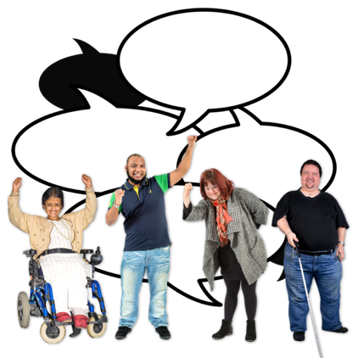

This part of the guide has advice about the right words to use when talking about disability like:
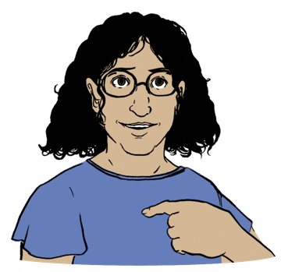
respectful words
inclusive words
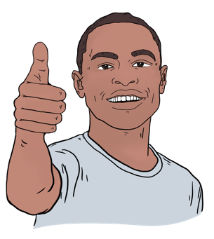
accepted terms like disabled people
words the person you are talking to likes to use.
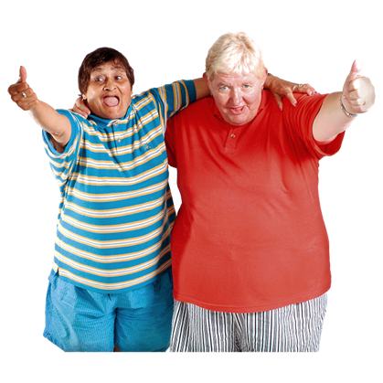
Respectful means having care for:
who people are
all the things about a person.

Accepted terms means the words that a community has decided are the right ones to use for them.

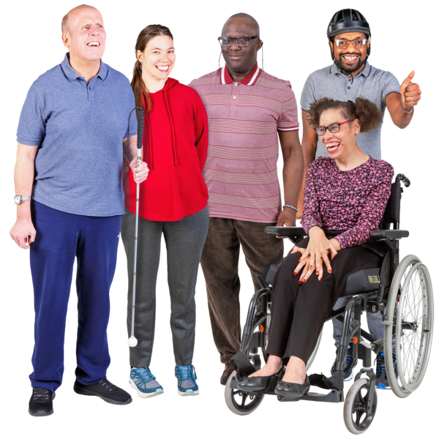

About DEI in outdoor activities

DEI stands for:
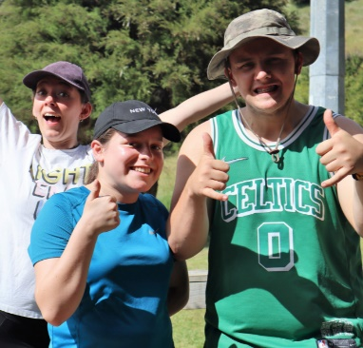
diversity
equity
inclusion.
Image source:
Halberg Foundation

Diversity means how people have different:
things that are part of who they are
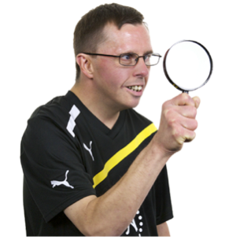
backgrounds which means the type of life they had before now
ways of looking at the world.

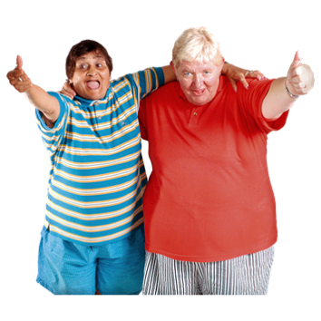
Equity means that:
different people start from different places in the world
different people need different types of support.

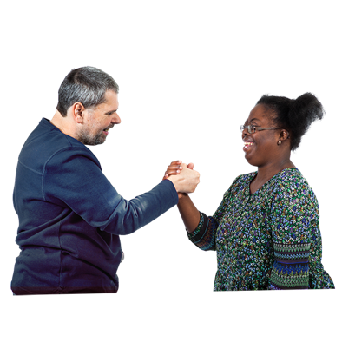
Inclusion means creating spaces where everyone:
feels welcome
can fully join in.
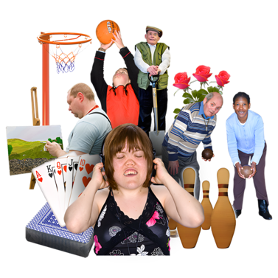
DEI is important because it helps make activities for all of the communities in Aotearoa New Zealand.

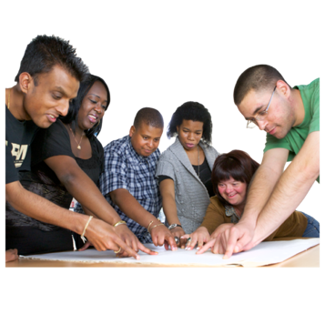
Different communities in Aotearoa New Zealand:
have different needs
should all be able to be a part of society.
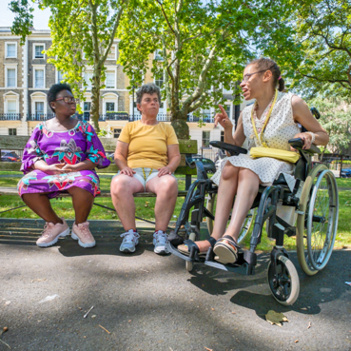

The guide talks about how DEI works in outdoor activities.

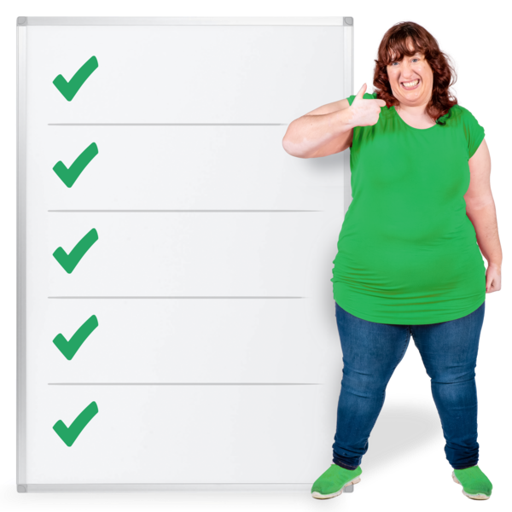
How to include everyone

The guide gives advice about how to make outdoor activities that:
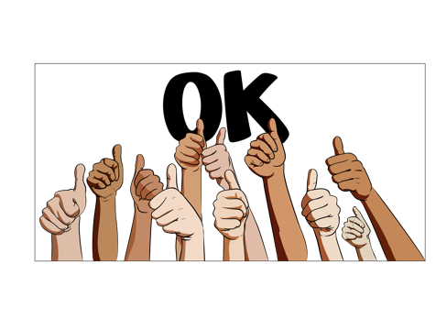
are safe to do
are welcoming for everyone
make every person feel valued.
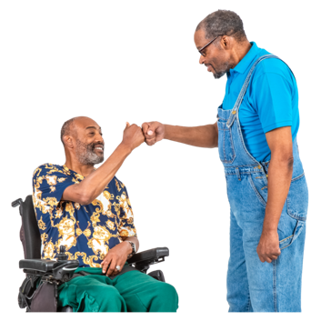

The guide gives different ways to make people feel like part of the group such as how to:
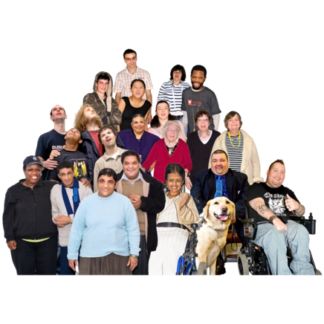
include everyone
bring all the people together
keep everyone safe.


Guiding frameworks / mindsets

The guide includes some:
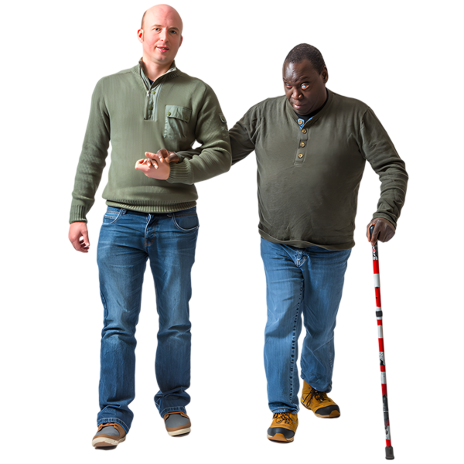
guiding frameworks to use when making activities more inclusive of disabled people
mindsets to think from when making outdoor activities.
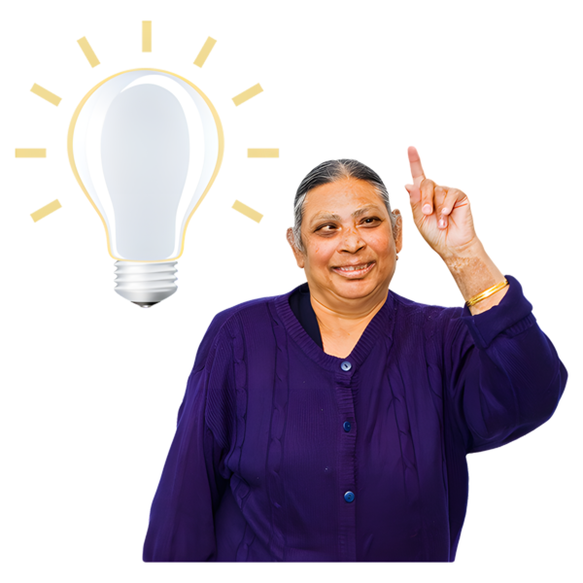

Frameworks are ideas you can use when making something new so that you do not need to start from the beginning.
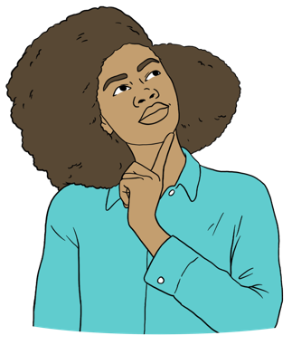

Mindsets are ways of thinking about things that assist you to see more about a topic.

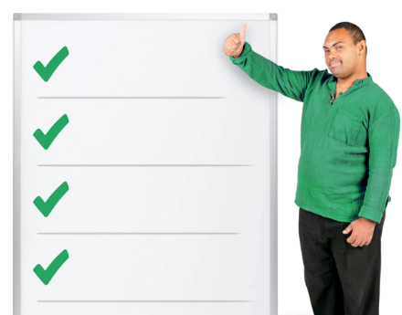
There are 4 frameworks / mindsets:
- Te Whare Tapa Whā
- Mana Taiohi
- United Nations Article 30
- Enabling Good Lives.

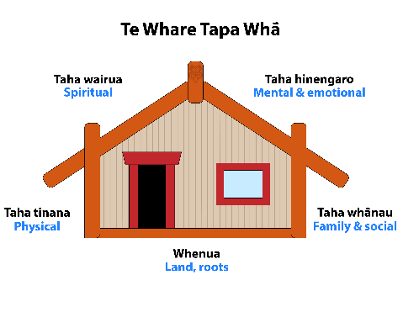
Te Whare Tapa Whā

Te Whare Tapa Whā is a Māori wellbeing framework about balance between all the different parts of the wellbeing of a person.
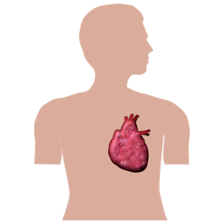

Wellbeing means how good you feel in your:
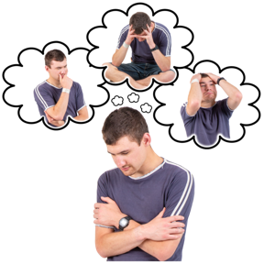
body
mind.

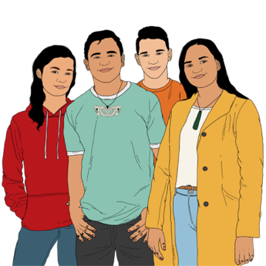
Mana Taiohi

Mana Taiohi is a set of guidelines about assisting rangatahi / young people to grow up well in Aotearoa New Zealand.

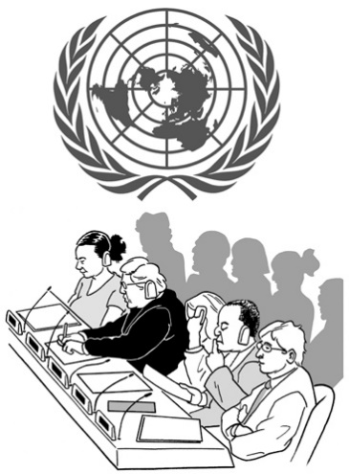
United Nations Article 30

United Nations Article 30:
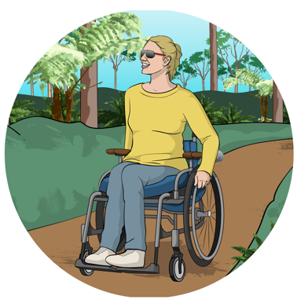
is a part of the agreement between different countries how countries should look after their people
says that countries should make sure disabled people can access recreation.

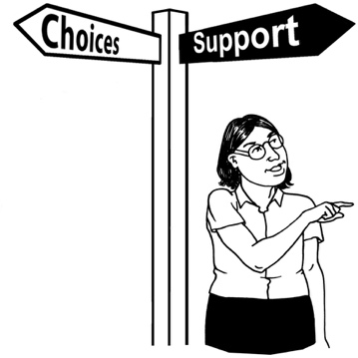
Enabling Good Lives

Enabling Good Lives is a different way of thinking about support.

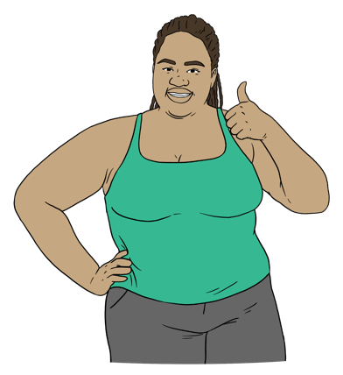
Enabling Good Lives is about having:
choice / control in your life
the support you need / want
a good life.

Policies

A policy is a set of rules an organisation makes about how they will do something.

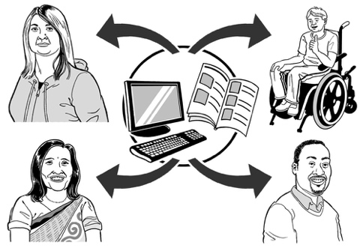
The guide talks about how DEI policies must be shared with all people in their organisation so that:
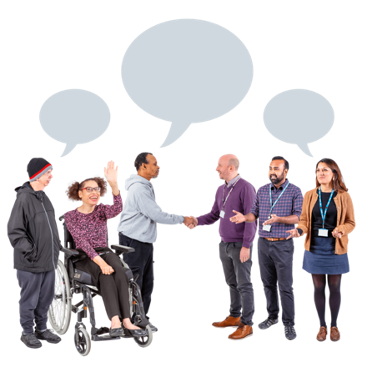
everyone knows what the DEI policy is
everyone knows how they can be part of making an inclusive environment.

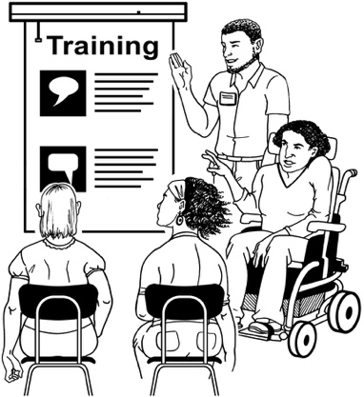
Inclusion training

Inclusion training is for staff to:
teach them what inclusion is
assist them to be more inclusive of the people who use a service.

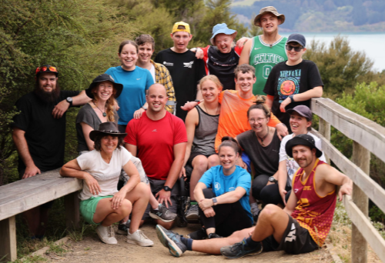
The guide also talks about how to do inclusion training that:
builds staff confidence
makes sure the DEI policies are used well.
Image source:
Halberg Foundation

Extra information for outdoor providers

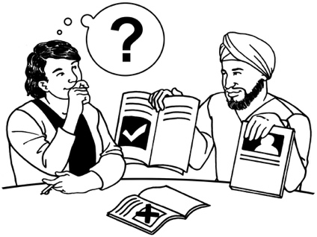
The guide gives extra information for outdoor recreation providers.

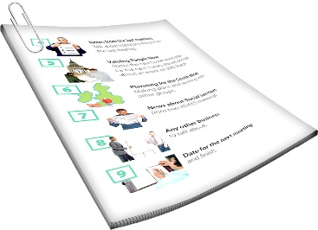
This part of the summary is some of the advice we give to outdoor providers.

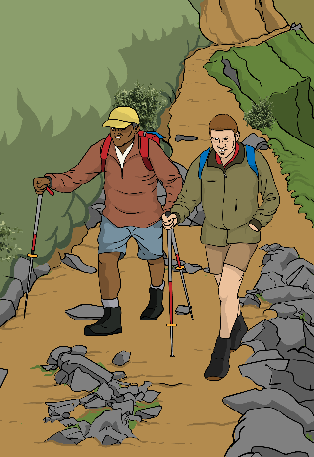
When we say you in this part we mean outdoor providers.


Communication

When making things for your business you should make:
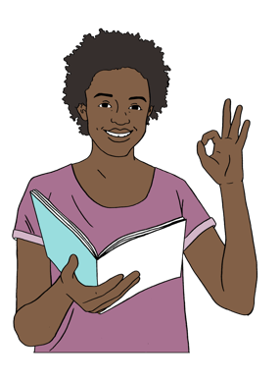
accessible websites
inclusive marketing materials.

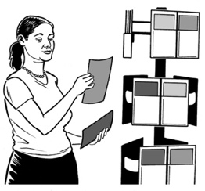
Marketing materials are things that tell people about a service like:
pamphlets
flyers
ads.


Many people will visit your website first.


Make sure your website:
is welcoming
is easy to use
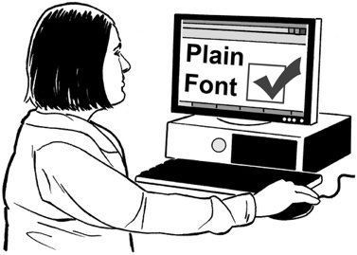
has clear information about what you offer.

The guide also advises you about making registrations forms that:
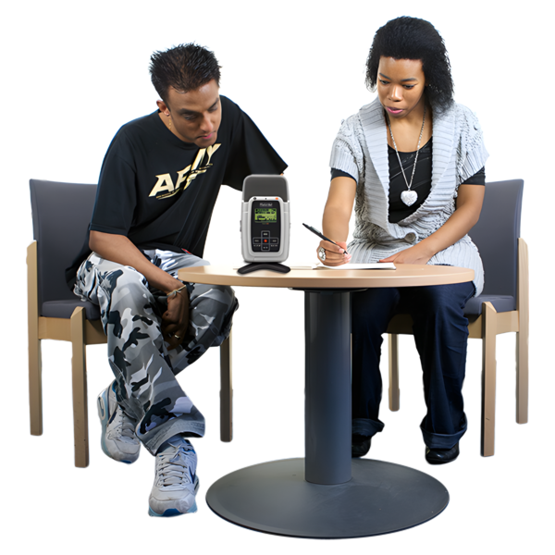
ask people the right questions
get all the information about the needs of people
have enough options to choose from to fit everyone.

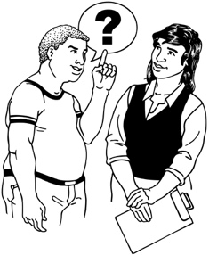
On registration forms:
ask people what makes them feel safe and happy
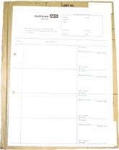
do not ask medical details
ask everyone about their needs.


Use different ways to communicate like visual aids.

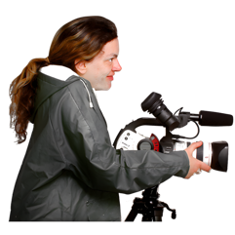
Assist people who will be doing the activities to prepare with:
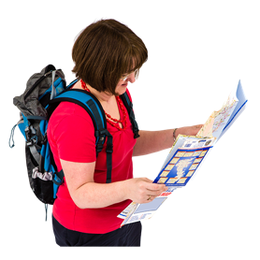
videos

maps
pictures.


Have 1 contact person with a phone number for questions.

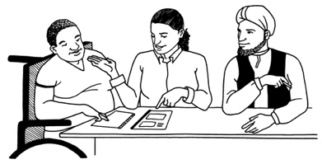
Making your activities suit different people

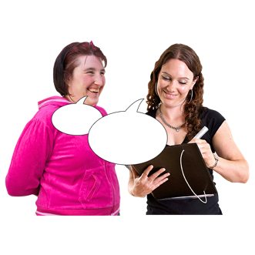
Work with each person to plan activities that are a good fit for them.

Ask the people who will be doing the activities for advice about what they need.
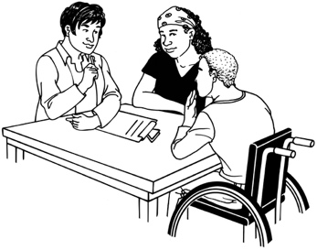

Also ask their support people for advice.

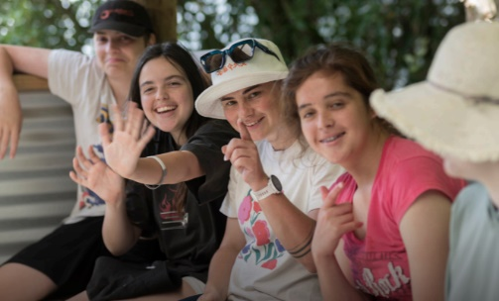
Spend time getting to know:
the people who will be doing the activities
their families.
Image source:
Whenua Iti Outdoors

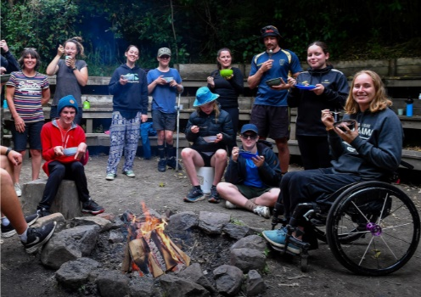
Overnight camps

Plan ahead to make sure everyone can join the camp.
Image source:
Halberg Foundation

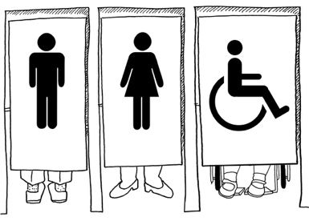
Choose a good place with easy access to:
toilets
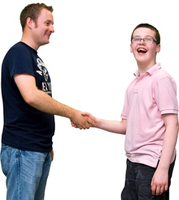
staff.

Use tents that are easy for everyone to:
get into
get out of.

Extra information for schools / educators

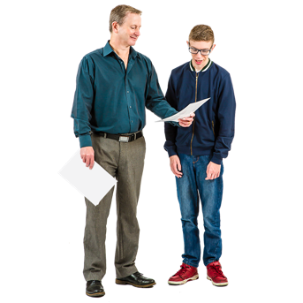
The guide gives some extra information for schools / educators about:
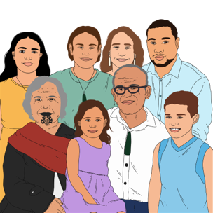
how to make outdoor classes accessible to everyone
working with ākonga / students
working with whānau / families
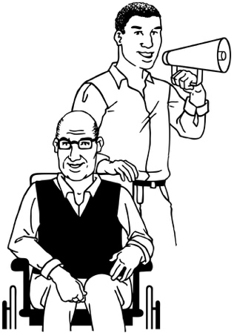
advocating for inclusive education outside the classroom.

Advocating means:
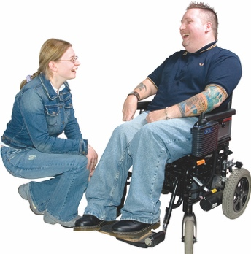
speaking up for other people
making sure other people get what they need.

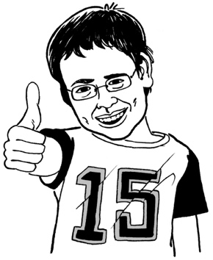
Schools can make great experiences for young people through outdoor activities.

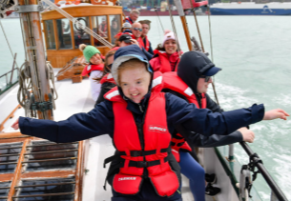
All students should be able to:
join in
learn in different environments / places.
Image source:
Halberg Foundation

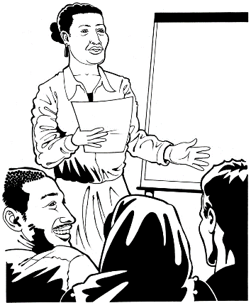
Teachers should get training / support to teach them how to assist all students to take part.

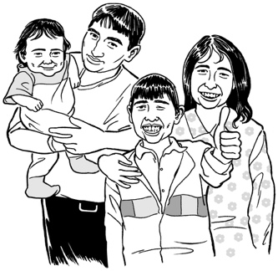
To know more about the support an ākonga / student needs ask the:
ākonga / student
their whānau / family.

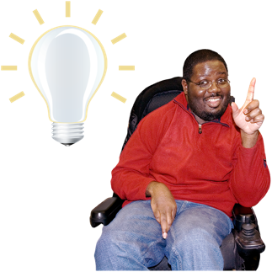
They know best about what support they need.

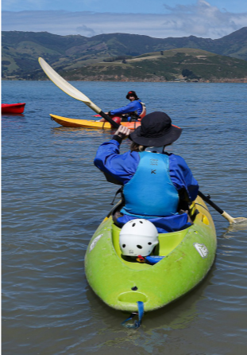
Plan carefully with whānau to make sure everyone feels:
safe
comfortable.
Image source:
Halberg Foundation

Show everyone how outdoor education can assist all students.
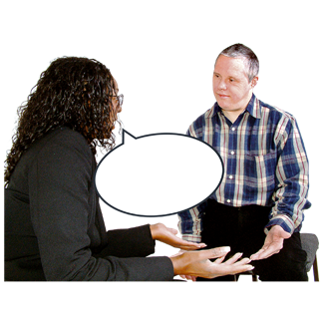

Work with outdoor providers to make sure they can support all students.

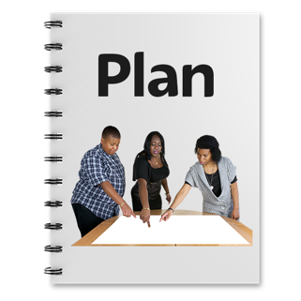
Share student support plans to make sure everyone knows all they need to.

Where to find more information

The guide gives some extra information including:
some case studies that show what you can do
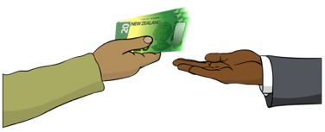
where to get funding
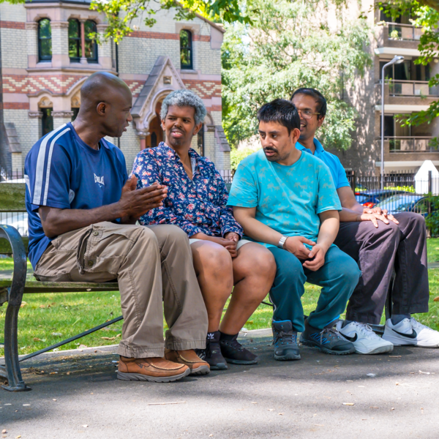
where to get training
links to some inclusive outdoor organisations
where to find more information.

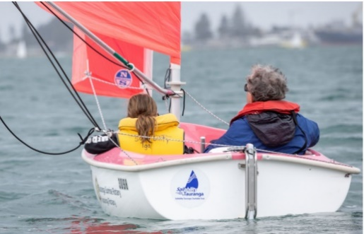
Case studies are information about what other people have done including:
how they did it
what was difficult about it
Image source:
Parafed Bay of Plenty, Sailability Tauranga

how they succeeded.

You can find the guide at this website:

sportnz.org.nz/resources/accessibility-and-inclusion-in-the-outdoors/

The guide has links to lots more information about inclusive outdoor activities.




This information has been written by Sport New Zealand Ihi Aotearoa, Recreation Aotearoa, and Education Outdoors New Zealand.

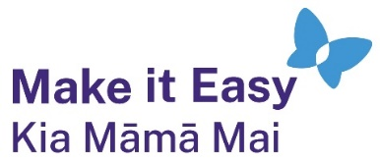
It has been translated into Easy Read by the Make it Easy Kia Māmā Mai service of People First New Zealand Ngā Tāngata Tuatahi.
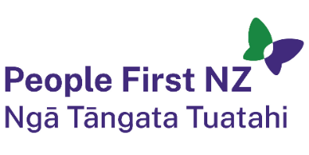
The ideas in this document are not the ideas of People First New Zealand Ngā Tāngata Tuatahi.

All images used in this Easy Read document are subject to copyright rules and cannot be used without permission.


Make it Easy uses images from:


- Photosymbols

- Change Images


- Huriana Kopeke-Te Aho

- SGC Image Works

- T Wood


- Studio Rebeko

- Inga Kramer.

