**Constitution Template – National Organisation**

**SUMMARY OF CHANGES IN NEW VERSION (JUNE 2024)**

The constitution template has been updated as at June 2024. It will be useful to look at this summary if you were part-way through updating your constitution based on the earlier version.

**Clause 1.2(e) (Interpretation):** new wording of “*any secondary legislation*” has been inserted.

#### ***(e)*** *A reference to any legislation includes any secondary legislation, statutory regulations, rules, orders or instruments made or issued pursuant to that legislation and any amendment to, re-enactment of, or replacement of, that legislation.*

#### 

**Clause 1.4(a) (Notices):** the word “*Business*” has been replaced with the word “*Working*” to correct the terminology used in the template.

### ***(a)*** *if given by post, when left at the address of a person or five ~~Business~~ Working Days after being put in the post; or*

**Clause 4.11 (Suspension of a Member):** the word “*invoking*” has been replaced with the word “*imposing*”.

### ***4.11*** *Before ~~invoking~~ imposing any such suspension, the Member must be given notice of the suspension.*

**Clause 6.2 (Composition):** a new paragraph and a new guidance note have been included to provide for the section 45(3) exemption relating to having a majority of independent board members.

### *This Constitution expressly provides for the majority of the Board to be made up of Officers who are not Members or representatives of bodies corporate that are Members.*

### *[Guidance note: You must include the last paragraph of clause 6.2 if your constitution requires or allows for the possibility that a majority of the Board will not be made up in the way required by section 45(3). See explanation in the next paragraph. In some cases, this might be very clear because your constitution has clauses that require a majority of the Board to be appointed by a process that only allows persons who are independent of the Members or the organisation to be eligible to apply. In other cases, anyone may be eligible to apply for election/appointment and, depending on the outcome of those processes, a majority of the Board could be persons who are not Members. If your constitution does not require elected or appointed Board members to be Members or representatives of bodies corporate that are Members, then it is possible you will not comply with section 45(3) and you should include this paragraph.*

**Clause 6.30 (Suspension of a Board Member):** tidy up changes are made to this paragraph.

### ***6.30*** *If a Board Member is or may be the subject of an allegation or notice relating to a matter described under clause 6.22* *or any other circumstances arise in relation to a Board Member which are or may be of concern to the Board, the remaining Board Members may by, Special Resolution, suspend the Board Member from the Board and set ~~such other~~ conditions ~~as~~ it requires pending the final determination of ~~such~~ the allegation, notice or circumstances. Before ~~invoking~~ imposing any ~~such~~ suspension, the Board Member must be given notice of the suspension.*

**Clause 6.32 (Removal of a Board Member):** a tidy up change is made to this paragraph.

### ***6.32*** *Before considering a motion for removal, the Board Member ~~affected~~ who is the subject of the motion must be given:*

**Clause 16.1 (Bylaws):** the words “*this Constitution*” have been inserted, as well as a new guidance note.

### ***16.1*** *The Board may make and amend Bylaws for the conduct and control of [organisation name]’s activities and codes of conduct applicable to Members. Any Bylaw must be consistent with this Constitution, the Purposes, the Act and any other laws. All Bylaws are binding on [organisation name] and the Members. [Guidance note: Section 28(2), Inc Soc Act provides that a Bylaw purportedly made by a society has no effect to the extent that it contravenes, or is inconsistent with, the Act, any other legislation or the society’s constitution.]*

**Clauses 17.1 and 17.2 (Integrity):** a sub-heading of ‘*Anti-doping’* is inserted and changes are made to both clauses with new wording in yellow highlighting.

*Anti-doping*

### ***17.1*** *[organisation name] adopts the Sports Anti-Doping Rules (****SADR****) made by Drug Free Sport New Zealand (until this is succeeded by the Integrity Sport and Recreation Commission), pursuant to the Sports Anti-Doping Act 2006 (until the Integrity Sport and Recreation Act 2023 comes into force ~~and any amendments to or replacements of SADR~~) as its Bylaws on anti-doping and agrees to be bound by SADR.* *All Members:*

#### *agree to* *the application of SADR; and*

#### *must require in their constitutions that their members agree to the application of SADR. [Guidance note: This clause doesn’t need to be included in your constitution if your anti-doping policy covers this. Once the Commission is operational (which under the ISRA is no later than 1 July 2024), DFSNZ will be part of the Commission and the SADR will be made by the Commission. Use this clause if you re-register before 1 July 2024.]*

### ***17.2*** *[organisation name] adopts the Sports Anti-Doping Rules (****SADR****) made by the Integrity Sport and Recreation Commission under the Integrity Sport and Recreation Act 2023~~, and any amendments to or replacements of SADR,~~ as its Bylaws on anti-doping and agrees to be bound by SADR. All Members:*

#### *agree to the application of SADR; and*

#### *must require in their constitutions that their members agree to the application of SADR. [Guidance note: Use this clause if you re-register after 1 July 2024.]*

**Clauses 17.3 to 17.5 (Integrity):** A sub-heading of “Integrity Code” is inserted. A new guidance note (which replaces the previous guidance note) and new clauses are included.

*Integrity Code*

*[**Guidance note: The* [*Integrity Sport and Recreation Act 2023*](https://legislation.govt.nz/act/public/2023/0048/latest/whole.html#LMS787103) *(****ISRA****), which provides for a new Integrity Sport and Recreation Commission (****Commission****), comes into force no later than 1 July 2024. The Commission will issue the Code of Integrity for Sport and Recreation (****Integrity Code****) after 1 July 2024.*

*Sport New Zealand Ihi Aotearoa’s initial recommendation was for organisations to consider holding off re-registering under the Inc Soc Act until the Integrity Code is clarified. As at 1 June 2024 the requirements for adoption of an integrity code are still in the drafting stages so the updated recommendation is that if the organisation feels ready to proceed with re-registration it should do so and deal with any additional changes later.*

*The recommended approach is to authorise the national sport/recreation organisation to adopt an integrity code, given that these organisations will generally be the governing body for the activity in New Zealand. Clauses 17.3 to 17.5 are provided as an example of how a national organisation might enable the effective application of an integrity code across a sport or recreation. The clauses do not predetermine that an organisation will adopt any specific integrity code but provide a framework for consistent application where organisations choose to adopt.* *The clauses may need adjustment to be consistent with the requirements for adoption of the integrity code and depending on your membership structure.*

*An integrity code adopted by a national sport/recreation organisation will bind its members automatically, which these clauses recognise.*

*These clauses do not capture non-members and do not require that organisations that are bound by an integrity code obtain agreement from non-member participants to be bound by the integrity code as a condition of their participation in events, competitions or activities which they organise, authorise or govern. Further guidance on this may be provided by the Commission at a later date.*

*Adopting an integrity code will mean your organisation will need to comply with any minimum standards or other obligations contained in that integrity code. These obligations may take immediate effect, while for others there may be a period of time following adoption before the minimum standard needs to be met. In either case, it will be important to work with the Commission and other organisations in your membership structure to make sure you understand the implications of adopting a particular integrity code as early as possible.*

*If you are part of a federated structure (or a hybrid structure where some members of the regional bodies, clubs or other tiers are not directly members of the national organisation), include clause 17.5 to allow for a cascading regime of clauses which bind each membership level in your structure. Clauses relating to the integrity code will need to be included in the constitutions of your regional organisations and clubs that have members who are not directly members of the national organisation. Whether a similar cascading regime can be adjusted to apply to unincorporated societies will depend on the circumstances relating to them. Further guidance will be required for these types of body.*

*A unitary structure (or a hybrid structure where all organisations and individuals are directly members of the national organisation) will not require the inclusion of clause 17.5 because all individuals are directly members of the national organisation, so they will all be bound by an integrity code adopted by their national organisation.]*

### ***17.3*** *In this clause 17* ***Integrity Code*** *means an integrity code issued by the Integrity Sport and Recreation Commission under section 19 of the Integrity Sport and Recreation Act 2023.*

### ***17.4*** *If [organisation name] adopts an Integrity Code, the Members of [organisation name] are bound by the Integrity Code.* *[Guidance note: Section 21(2)(b)(i), ISRA.]*

### ***17.5*** *All Regional Bodies mus**t include in their constitution that if [organisation name] adopts an Integrity Code the members of the Regional Bodies agree to the application of the Integrity Code to them and agree to be bound by it and must require that its members include a similar clause in their constitutions. [Guidance note: Include and amend as required for your membership structure.]*

**Clause 18 (Dispute resolution)**: Some changes are made to the guidance note with new wording in yellow highlighting. A new example disputes resolution clause is included. Note there is a small change to an existing clause 18.18 (Sports Tribunal) which was previously numbered clause 18.1.

*[Guidance note:*

*…*

*You will need to think carefully through all the policies and regulations that sit outside your constitution that contain dispute elements and consider how these flow through your membership structure. This may be an opportunity to set up an aligned and integrated disputes resolution procedure within a sport’s network. Consider whether your organisation can assist your regional organisations and clubs with guidance or appropriate dispute resolution procedures as they prepare to re-register.*

*…*

*Sport New Zealand Ihi Aotearoa’s ~~recommends~~ approach was to recommend organisations consider holding off re-registering under the Inc Soc Act until this is clarified. The updated recommendation as at June 2024 is that if the organisation feels ready to proceed it should do so and deal with any additional changes later.]*

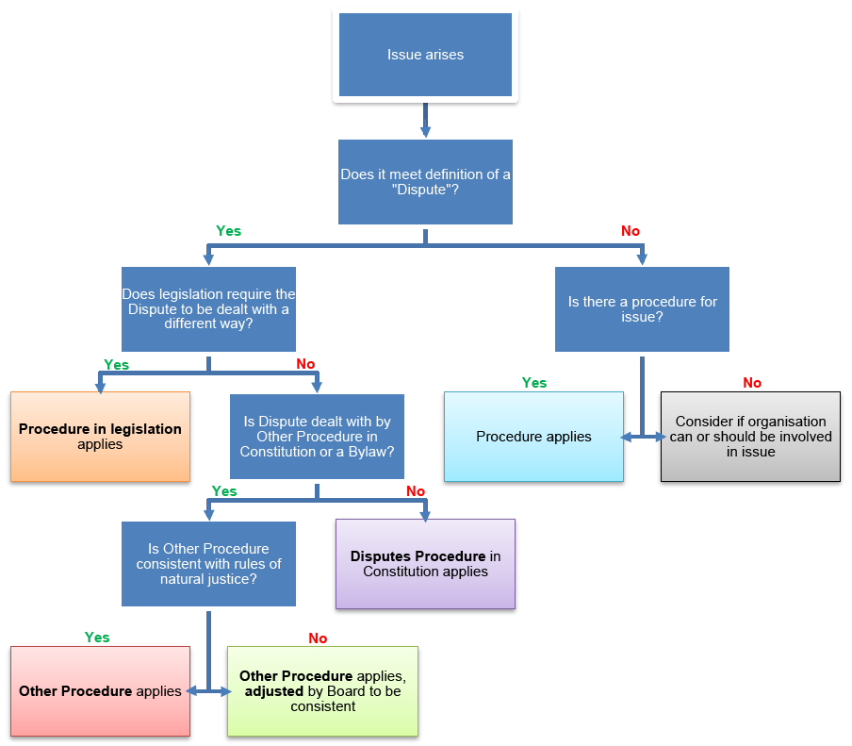

*Definitions*

### ***18.1*** *In this clause 18:*

#### ***Dispute*** *means a disagreement or conflict between and among any one or more Members, any one or more Officers and [organisation name], that relates to an allegation that:*

##### *a Member or an Officer has engaged in misconduct; or*

##### *a Member or an Officer has breached, or is likely to breach, a duty under this Constitution or the Act; or*

##### *[Organisation name] has breached, or is likely to breach, a duty under this Constitution or the Act; or*

##### *a Member’s rights or interests as a member have been damaged or Members’ rights or interests generally have been damaged; [Guidance note: Section 38(1), Inc Soc Act.]*

#### ***Disputes Procedure*** *means the procedure for resolving a Dispute set out in clauses 18.6 to 18.19;*

#### *a* ***Member*** *is a reference to a Member acting in their capacity as a Member; [Guidance note: Section 38(3)(a), Inc Soc Act.]*

#### *an* ***Officer*** *is a reference to an Officer acting in their capacity as an Officer. [Guidance note: Section 38(3)(b), Inc Soc Act.]*

*Application of other legislation to a Dispute*

### ***18.2*** *The Disputes Procedure will not apply to a Dispute to the extent that other legislation requires the Dispute to be dealt with in a different way. The Disputes Procedure will have no effect to the extent that it contravenes, or is inconsistent with, that legislation. [Guidance note: Section 42(2), Inc Soc Act. As examples, the Employment Relations Authority has exclusive jurisdiction to make determinations about employment relationships problems; the Sports Tribunal hears appeals against decisions of national sporting organisations if that organisation’s constitution provides for it; and, if provided for in an integrity code, the Integrity Commission may establish a disciplinary panel to determine breaches of an integrity code.]*

*Application of other procedures under this Constitution or in a Bylaw*

### ***18.3*** *If the Dispute is dealt with by a separate procedure under this Constitution or in a Bylaw (****Other Procedure****), that Other Procedure applies to the exclusion of the Disputes Procedure. If any part of the Other Procedure is inconsistent with the rules of natural justice, that part will not apply, but the remainder of the Other Procedure will continue to apply together with adjustments as determined by the Board in its discretion so that the Other Procedure is consistent with the rules of natural justice. [Guidance note: For example, there is a separate procedure in this Constitution for removing a Board Member at clauses 6.31 and 6.32. You must make it clear to your Members where these Other Procedures are found and ensure that they are easy to access. Bylaws is an umbrella term used to cover bylaws, policies, regulations and codes that your organisation might have e.g. policies on competition manipulation, selection appeals, corruption and fraud, member protection, code of conduct and rules of the game.]*

### ***18.4*** *If the conduct, incident, event or issue does not meet the definition of a Dispute and is managed by any Other Procedure, that Other Procedure applies to the exclusion of the Disputes Procedure.*

*Application of the Disputes Procedure*

### ***18.5*** *If the Dispute is not required by other legislation to be dealt with in a different way and it is not dealt with by any Other Procedure, the Disputes Procedure applies to the Dispute.*

*Disputes Procedure*

### ***Raising a complaint*** *[Guidance note: Section 38(2) and cl 2, Sch 2, Inc Soc Act.]*

### ***18.6*** *A Member or an Officer may start the Disputes Procedure (a* ***Complaint****) by giving written notice to the Board setting out:*

#### *the allegation to which the dispute relates and who the allegation is against; and*

#### *any other information reasonably required by [organisation name].*

### ***18.7*** *[Organisation name] may make a Complaint involving an allegation against a Member or an Officer by giving notice to the person concerned setting out the allegation to which the Dispute relates.*

### ***18.8*** *The information given must be enough to ensure a person against whom the Complaint is made is fairly advised of the allegation concerning them, with sufficient details given to enable them to prepare a response.*

### ***Investigating and determining Disputes*** *[Guidance note: Cl 5, Sch 2, Inc Soc Act.]*

### ***18.9*** *Unless otherwise provided, [organisation name] must as soon as is reasonably practicable after receiving or becoming aware of a Complaint, ensure the Dispute is investigated and determined.*

### ***18.10*** *Disputes must be dealt with in a fair, efficient, and effective manner.*

### ***Decision to not proceed with a matter*** *[Guidance note: Cl 6, Sch 2, Inc Soc Act, modified.]*

### ***18.11*** *Despite the contents of the Disputes Procedure, [organisation name] may decide not to proceed with a matter if:*

#### *the Complaint is trivial; or*

#### *the Complaint does not appear to disclose or involve any allegation of the following kind:*

##### *any material misconduct; or*

##### *any material breach or likelihood of material breach of a duty under this Constitution or the Act; or*

##### *any material damage to a Member’s rights or interests or Members’ rights or interests generally; or*

#### *the Complaint appears to be without foundation or there is no apparent evidence to support it; or*

#### *the person who makes the Complaint has an insignificant interest in the matter; or*

#### *the conduct, incident, event, or issue giving rise to the Complaint has already been investigated and dealt with under this Constitution; or*

#### *there has been an undue delay in making the Complaint; or*

#### *the Complaint involves two Members who are also members of an organisation (****Organisation X****) which is also a Member of [organisation name] and the Complaint has either been dealt with by Organisation X or is required to be, pursuant to the dispute resolution procedures of Organisation X. [Guidance note: Optional to include sub-clause (g). This sub-clause covers a situation in a hybrid federated model where, for example, 2 members of a club, who are also both members of the national organisation, have a Dispute. This sub-clause allows the Dispute to be dealt with at the appropriate level.]*

### ***Complaint may be referred*** *[Guidance note: Cl 7, Sch 2, Inc Soc Act, modified.]*

### ***18.12*** *[Organisation name] may refer a Complaint to:*

#### *a hearing body or person authorised, delegated or appointed by the Board to hear and resolve Disputes, and includes an arbitral tribunal (****Hearing Body****); or*

#### *a subcommittee or an external person to investigate and report; or*

#### *any type of consensual dispute resolution with the consent of all parties to the Complaint. [Guidance note: Examples are mediation, facilitation or a tikanga-based practice.]*

### ***Hearing Body***

### ***18.13*** *The Board may determine the composition, jurisdiction, functions and procedures of, and any sanctions which can be imposed by, any Hearing Body. Each Hearing Body has delegated authority by the Board to resolve, or assist to resolve, Complaints.*

### ***Bias*** *[Guidance note: Cl 8, Sch 2, Inc Soc Act.]*

### ***18.14*** *An individual may not be part of a Hearing Body in relation to a Complaint if two or more members of the Board or of the Hearing Body consider there are reasonable grounds to believe that the individual may not be:*

#### *impartial; or*

#### *able to consider the matter without a predetermined view.*

### ***Complainant’s right to be heard*** *[Guidance note: Cl 3, Sch 2, Inc Soc Act.]*

### ***18.15*** *The Member or Officer has a right to be heard before the Complaint is resolved or any outcome is determined. If* *[organisation name] makes a Complaint, [organisation name] has a right to be heard before the Complaint is resolved or any outcome is determined, and a Board Member may exercise that right on behalf of [organisation name].*

### ***18.16*** *A Member or Officer or [organisation name] must be taken to have been given the right if:*

#### *the Member or Officer or [organisation name] has a reasonable opportunity to be heard in writing or at an oral hearing, if one is held; and*

#### *an oral hearing is held if the Hearing Body considers that an oral hearing is needed to ensure an adequate hearing; and*

#### *an oral hearing, if any, is held before the Hearing Body; and*

#### *the Member’s or Officer’s or [organisation name]’s written statement or submission, if any, are considered by the Hearing Body.*

### ***Respondent’s right to be heard*** *[Guidance note: Cl 4, Sch 2, Inc Soc Act.]*

### ***18.17*** *The Member or Officer who, or [organisation name] which, is the subject of the Complaint (****Respondent****) has a right to be heard before the Complaint is resolved or any outcome is determined. If the Respondent is [organisation name], a Board Member may exercise the right on behalf of [organisation name]. A Respondent must be taken to have been given the right if:*

#### *the Respondent is fairly advised of all allegations concerning the Respondent, with sufficient details and time given to enable the Respondent to prepare a response; and*

#### *the Respondent has a reasonable opportunity to be heard in writing or at an oral hearing, if one is to be held; and*

#### *an oral hearing is held if the Hearing Body considers that an oral hearing is needed to ensure an adequate hearing; and*

#### *an oral hearing, if any, is held before the Hearing Body; and*

#### *the Respondent’s written statement or submissions, if any, are considered by the Hearing Body.*

### ***Appeals***

### *[Guidance note: Your constitution may provide for whether and, if so, how a decision made under the procedures for resolving disputes may be subject to an appeal or review, section 44, Inc Soc Act. Consider what rights of appeal or review are available (if any) and to what body they may be appealed to or reviewed by. In short, a right of appeal allows a party to apply to a different or higher body to determine whether the original decision was correct. A right of review is a more confined right where a reviewer looks at whether the way the original decision was made was lawful, reasonable and procedurally correct. The reviewer usually won’t decide whether the decision was the ‘right decision’.]*

### ***18.18*** *Unless this Constitution or any Bylaw provides otherwise, any Member wishing to appeal a decision of [organisation name] regarding [insert which matters have appeal rights to the Sports Tribunal] where they have exhausted their rights of appeal within this Constitution and/or ~~the Bylaws~~ any Bylaw, may appeal to the Sports Tribunal of New Zealand. The rules of the Sports Tribunal of New Zealand apply to any such appeal. [Guidance note: The Sports Tribunal can hear an appeal against a decision of a ~~NSO~~ national sporting organisation if their constitution specifically provides for an appeal to the Tribunal in relation to that matter – section 38(c), Sports Anti-Doping Act 2006. You will need to include this clause if you wish this to occur and to specify which matters can be appealed to the Tribunal. Once ISRA is in force (no later than 1 July 2024), ISRA amends the title of the Sports Anti-Doping Act 2006 to be the Sports Tribunal Act 2006 and amends that Act so the Tribunal can also determine disputes arising from the application of an integrity code, hear an appeal against a decision of a disciplinary panel under subpart 4 of Part 4 of ISRA and hear an appeal against a decision of a disciplinary body established by an organisation that has adopted an integrity code.]*

### ***18.19*** *There is no right of appeal or right of review of a decision unless specified. [Guidance note: Optional to include.]*