Constitution Template – Club – Version A

SUMMARY OF CHANGES IN NEW VERSION (JUNE 2024)

The constitution template has been updated as at June 2024. It will be useful to look at this summary if you were part-way through updating your constitution based on the earlier version.

Clause 1.2(e) (Interpretation): new wording of “any secondary legislation” has been inserted.

(e) A reference to any legislation includes any secondary legislation, statutory regulations, rules, orders or instruments made or issued pursuant to that legislation and any amendment to, re-enactment of, or replacement of, that legislation.

Clause 1.4(a) (Notices): the word “Business” has been replaced with the word “Working” to correct the terminology used in the template.

(a) if given by post, when left at the address of a person or five Business Working Days after being put in the post; or

Clause 6.8 (Suspension of a Committee Member): a tidy up change is made to this paragraph.

If any Committee Member is or may be the subject of an allegation, notice or charge described under the sub-clause headed “Disqualification” clause 6.5…

Clause 6.9(c) (Removal of a Committee Member): a tidy up change is made to this paragraph.

(c) Before considering a motion for removal, the Board Member affected who is the subject of the motion must be given:

Clause 12.4(b) (No personal benefit): the word “organisation” has been replaced with the word “Club”.

(b) entering into any transactions with the organisation Club for goods or services

Clause 14 (Bylaws): the words “and Integrity” have been added to the title. The words “this Constitution” have been inserted in clause 14.1, as well as a new guidance note.
New clauses 14.2 to 14.4 and a guidance note have been inserted.

14 Bylaws and Integrity

14.1 The Committee may make and amend Bylaws for the conduct and control of [organisation name]’s activities and codes of conduct applicable to Members. Any Bylaw must be consistent with this Constitution, the Purposes, the Act and any other laws. All Bylaws are binding on [organisation name] and the Members. [Guidance note: Section 28(2), Inc Soc Act provides that a Bylaw purportedly made by a society has no effect to the extent that it contravenes, or is inconsistent with, the Act, any other legislation or the society’s constitution.]
[Guidance: As background, the Integrity Sport and Recreation Act 2023 (ISRA) provides for a new Integrity Sport and Recreation Commission (Commission), which comes into force no later than 1 July 2024. The Commission will issue the Code of Integrity for Sport and Recreation (Integrity Code) after 1 July 2024.
Your national organisation may choose to adopt an integrity code. If it does, the code will bind its members automatically. Clauses 14.2 to 14.4 are provided as an example to enable the effective application of an integrity code across a sport or recreation. Check with your national organisation to see if the clauses need to be adjusted before you re-register.
Include clause 14.4 if your club is part of a federated or hybrid structure, and all of your club members are not directly members of the national organisation. If all your members are directly members of the national organisation, clause 14.4 is not required, but you can still include it if you want to reiterate to your members that they are bound.

14.2 Definition: In this clause 14.2 Integrity Code means an integrity code issued by the Integrity Sport and Recreation Commission under section 19 of the Integrity Sport and Recreation Act 2023.

14.3 Integrity Code binding: If [national organisation] adopts an Integrity Code, the Club agrees to the application of the Integrity Code to it and agrees to be bound by it. [Guidance: Section 21(2)(b)(i), ISRA.]

14.4 Application to Members: If [national organisation] adopts an Integrity Code, all Members of the Club agree to the application of the Integrity Code to them and agree to be bound by it.

Clause 15 (Dispute resolution): A new paragraph is added to the guidance. A new example disputes resolution clause is included.
The following clauses provide an example of how an organisation might manage disputes and other matters arising that are dealt with under policies or regulations, while ensuring that it complies with the Inc Soc Act requirements, as well as providing a dispute resolution procedure which is largely based on Sch 2 of the Act. The flow chart below helps to determine the correct procedure for handling a certain dispute or other matter.]

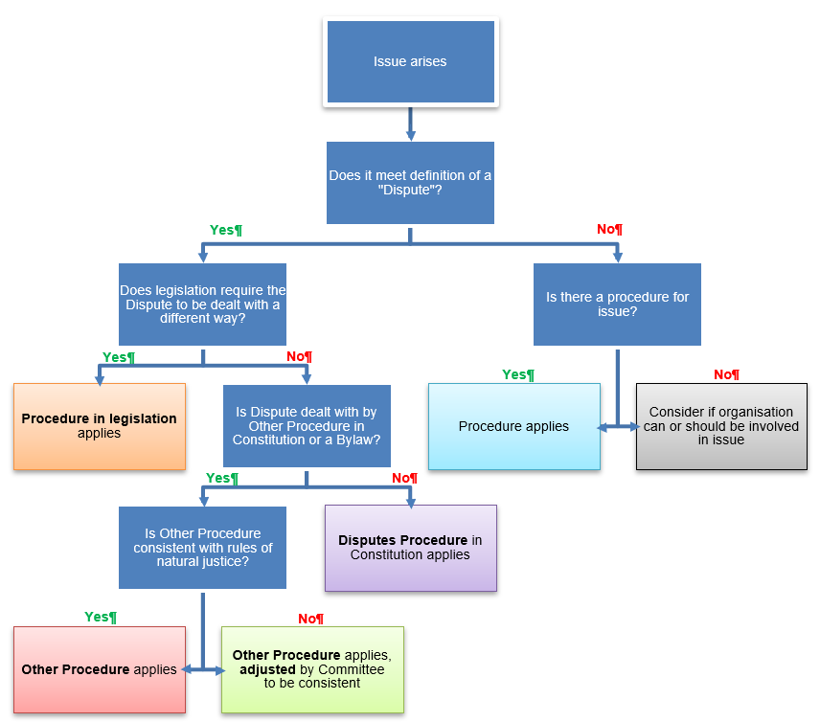

15.1 Definitions: In this clause 15:

Dispute means a disagreement or conflict between and among any one or more Members, any one or more Officers and the Club, that relates to an allegation that:

a Member or an Officer has engaged in misconduct; or

a Member or an Officer has breached, or is likely to breach, a duty under this Constitution or the Act; or

the Club has breached, or is likely to breach, a duty under this Constitution or the Act; or

a Member’s rights or interests as a member have been damaged or Members’ rights or interests generally have been damaged; [Guidance: Section 38(1), Inc Soc Act.]

Disputes Procedure means the procedure for resolving a Dispute set out in clauses 15.5 to 15.13;

a Member is a reference to a Member acting in their capacity as a Member; [Guidance: Section 38(3)(a), Inc Soc Act.]

an Officer is a reference to an Officer acting in their capacity as an Officer. [Guidance: Section 38(3)(b), Inc Soc Act.]

15.2 Application of other legislation to a Dispute: The Disputes Procedure will not apply to a Dispute to the extent that other legislation requires the Dispute to be dealt with in a different way. The Disputes Procedure will have no effect to the extent that it contravenes, or is inconsistent with, that legislation. [Guidance: Section 42(2), Inc Soc Act. As examples, the Employment Relations Authority has exclusive jurisdiction to make determinations about employment relationships problems.]

15.3 Application of other procedures under this Constitution or in a Bylaw:

If the Dispute is dealt with by a separate procedure under this Constitution or in a Bylaw (Other Procedure), that Other Procedure applies to the exclusion of the Disputes Procedure. If any part of the Other Procedure is inconsistent with the rules of natural justice, that part will not apply, but the remainder of the Other Procedure will continue to apply together with adjustments as determined by the Committee in its discretion so that the Other Procedure is consistent with the rules of natural justice. [Guidance: For example, there is a separate procedure in this Constitution for removing a Committee Member at clause 6.9. You must make it clear to your Members where these Other Procedures are found and ensure that they are easy to access. Bylaws is an umbrella term used to cover bylaws, policies, regulations and codes that your organisation might have e.g. code of conduct and rules of the game.]

If the conduct, incident, event or issue does not meet the definition of a Dispute and is managed by any Other Procedure, that Other Procedure applies to the exclusion of the Disputes Procedure.

15.4 Application of the Disputes Procedure: If the Dispute is not required by other legislation to be dealt with in a different way and it is not dealt with by any Other Procedure, the Disputes Procedure applies to the Dispute.

Disputes Procedure

15.5 Raising a complaint:

A Member or an Officer may start the Disputes Procedure (a Complaint) by giving written notice to the Committee setting out:

the allegation to which the dispute relates and who the allegation is against; and

any other information reasonably required by the Club.

The Club may make a Complaint involving an allegation against a Member or an Officer by giving notice to the person concerned setting out the allegation to which the Dispute relates.

The information given must be enough to ensure a person against whom the Complaint is made is fairly advised of the allegation concerning them, with sufficient details given to enable them to prepare a response. [Guidance: Section 38(2) and cl 2, Sch 2, Inc Soc Act.]

15.6 Investigating and determining Disputes: Unless otherwise provided, the Club must as soon as is reasonably practicable after receiving or becoming aware of a Complaint, ensure the Dispute is investigated and determined. Disputes must be dealt with in a fair, efficient, and effective manner. [Guidance: Cl 5, Sch 2, Inc Soc Act.]

15.7 Decision to not proceed with a matter: Despite the contents of the Disputes Procedure, the Club may decide not to proceed with a matter if:

the Complaint is trivial; or

the Complaint does not appear to disclose or involve any allegation of the following kind:

any material misconduct; or

any material breach or likelihood of material breach of a duty under this Constitution or the Act; or

any material damage to a Member’s rights or interests or Members’ rights or interests generally; or

the Complaint appears to be without foundation or there is no apparent evidence to support it; or

the person who makes the Complaint has an insignificant interest in the matter; or

the conduct, incident, event, or issue giving rise to the Complaint has already been investigated and dealt with under this Constitution; or

there has been an undue delay in making the Complaint. [Guidance: Cl 6, Sch 2, Inc Soc Act.]

15.8 Complaint may be referred: The Club may refer a Complaint to:

a hearing body or person authorised, delegated or appointed by the Committee to hear and resolve Disputes, and includes an arbitral tribunal (Hearing Body); or

a subcommittee or an external person to investigate and report; or

any type of consensual dispute resolution with the consent of all parties to the Complaint. [Guidance: Cl 7, Sch 2, Inc Soc Act, modified. Examples are mediation, facilitation or a tikanga-based practice.]

15.9 Hearing Body: The Committee may determine the composition, jurisdiction, functions and procedures of, and any sanctions which can be imposed by, any Hearing Body. Each Hearing Body has delegated authority by the Committee to resolve, or assist to resolve, Complaints.

15.10 Bias: An individual may not be part of a Hearing Body in relation to a Complaint if two or more members of the Committee or of the Hearing Body consider there are reasonable grounds to believe that the individual may not be:

impartial; or

able to consider the matter without a predetermined view. [Guidance: Cl 8, Sch 2, Inc Soc Act.]

15.11 Complainant’s right to be heard:

The Member or Officer has a right to be heard before the Complaint is resolved or any outcome is determined. If the Club makes a Complaint, the Club has a right to be heard before the Complaint is resolved or any outcome is determined, and a Committee Member may exercise that right on behalf of the Club.

A Member or Officer or the Club must be taken to have been given the right if:

the Member or Officer or the Club has a reasonable opportunity to be heard in writing or at an oral hearing, if one is held; and

an oral hearing is held if the Hearing Body considers that an oral hearing is needed to ensure an adequate hearing; and

an oral hearing, if any, is held before the Hearing Body; and

the Member’s or Officer’s or the Club’s written statement or submission, if any, are considered by the Hearing Body. [Guidance: Cl 3, Sch 2, Inc Soc Act.]

15.12 Respondent’s right to be heard: The Member or Officer who, or the Club which, is the subject of the Complaint (Respondent) has a right to be heard before the Complaint is resolved or any outcome is determined. If the Respondent is the Club, a Committee Member may exercise the right on behalf of the Club. A Respondent must be taken to have been given the right if:

the Respondent is fairly advised of all allegations concerning the Respondent, with sufficient details and time given to enable the Respondent to prepare a response; and

the Respondent has a reasonable opportunity to be heard in writing or at an oral hearing, if one is to be held; and

an oral hearing is held if the Hearing Body considers that an oral hearing is needed to ensure an adequate hearing; and

an oral hearing, if any, is held before the Hearing Body; and

the Respondent’s written statement or submissions, if any, are considered by the Hearing Body. [Guidance: Cl 4, Sch 2, Inc Soc Act.]

15.13 Appeals: There is no right of appeal or right of review of a decision unless specified. [Guidance: Your constitution may provide for whether and, if so, how a decision made under the procedures for resolving disputes may be subject to an appeal or review, section 44, Inc Soc Act. Consider what rights of appeal or review are available (if any) and to what body they may be appealed to or reviewed by. Check in with your national and/or regional organisation to see if there are any rights of appeal or review. In short, a right of appeal allows a party to apply to a different or higher body to determine whether the original decision was correct. A right of review is a more confined right where a reviewer looks at whether the way the original decision was made was lawful, reasonable and procedurally correct. The reviewer usually won’t decide whether the decision was the ‘right decision’. This clause is optional to include.]

