

A nine-step introduction to social media for New Zealand sports bodies

SOCIAL MEDIA
Index

Introduction 3
Social Media Game Plan 4
Step 1: Analysis 4
Step 2: Appraise your audience 6
Step 3: Assess your resources 7
Step 4: Define your objectives 8
Step 5: Evaluate your options 9
Step 6: Make a plan 11
Step 7: Implementation 15
Step 8: Watch and learn 17
Step 9: Refine and improve 19
Checklist 20
Appendix A: Sample Social Media Content Plan 22
Appendix B: Sample moderation policy 23
Appendix C: Sample staff social media policy 24
Appendix D: Writing for social media 27
Appendix E: Athlete use of social media 28
Appendix F: Social Media Glossary 29
References 32

The author has made every effort to ensure that the information provided in this document is accurate and up to date. However the matters covered are subject to regular changes and review and no warranty or representation can be provided regarding the accuracy of such information. Neither the author nor Sport New Zealand accept liability for any losses or damage arising directly or indirectly from reliance on the information contained in this document.
Created by Clare Wolfensohn (Social Media Consultant) on behalf of Sport and Recreation New Zealand, January 2012.

Introduction

The game is changing. The emergence of social media and “Web 2.0” has brought a landslide of opportunities and challenges for all those associated with sport and recreation – clubs, participants, fans, administrators and everyone else with an interest.

Sports organisations can now use social media to:

- increase commercial opportunities
- reach and retain a larger fan base
- increase services to players

Social media also brings new risks which must be managed.

In starting to think about when and how to use the wide array of social media tools that are available, you have taken the first step on an exciting journey.

The Social Media Game Plan provides a nine-step process to help sports bodies, from national sports organisations to local clubs, identify ways in which social media can support the achievement of their goals. It also lays out a plan for assessing resources, risk and opportunities, and explains how to best use the tools that are available.

Using the Game Plan

The Social Media Game Plan assumes your organisation is not yet using social media, or if it is, doesn’t yet have a formal development and management plan in place. Working through this document will help you create this.

Each of the nine steps has its own series of questions to help clarify your thinking. If possible, try to answer these questions with a group of colleagues or other stakeholders, in order to maximise input and ideas.

If you don’t currently have an organisational account we recommend holding off creating one until you’ve worked through the Social Media Game Plan. Part of the reason for this is that it is important to secure support from your wider organisation before getting into social media.

Social Media Game Plan

1
Step 1: Analysis

2
Step 2: Appraise your audience

3
Step 3: Assess your resources

4
Step 4: Define your objectives

5
Step 5: Evaluate your options

6
Step 6: Make a plan

7
Step 7: Implementation

8
Step 8: Watch and learn

Step 9: Refine and improve
9

Step 1: Analysis

The basis of any good strategy is to clearly identify and understand the environment in which you are operating. Start off with a simple “SWOT” analysis to review your internal strengths and weaknesses and external environment (i.e. the opportunities and threats).

Strengths
- What does your organisation do well?
- What makes your organisation better than your competitors?
- What unique or low cost resources do you have available?

Examples: Competitive advantages, support from senior management, location, passionate fan base, skilled resources/people, a new product, etc.

Weaknesses
- What does your organisation not do well?
- What issues have you encountered in the past that may arise again?
- What should you avoid?

Examples: Lack of knowledge, lack of resources (time or funds), organisational support, effects on core activities, commitment, leadership, technology, etc.

Opportunities
- What trends are taking place in your market/sport/society?
- What stakeholders and partners can you join forces with?
- What areas could you realistically improve in?

Examples: Market developments (new markets, niche markets), technology changes, audience reach, lifestyle trends, media environment, etc.

Threats
- What could stop you from achieving in this area?
- What trends could pose a threat to your business?
- How could you mitigate (or counter) these risks?

Examples: Industry change, competitors, legislation, economy, loss of control, regulating employees or athletes, commercialisation, etc.

Step 2: Appraise your audience

Audience profiles
Sporting organisations have diverse audiences – athletes, coaches, volunteers, partners, sponsors and fans, to name a few. It is important to define and understand the audience groups you want to connect with, and who may be interested in connecting with you. You’ll need to know what they are looking for.

Questions for you
  - Which groups do you need to/want to communicate with?
  - Which groups need to/want to communicate with you?
  - What demographics do you already know about your audience?
  - Which key messages do you want them to know?
  - Which messages are they interested in receiving?
  - Who do they turn to or trust for information?

Examples

Audience | Characteristics | Interests | Influencers
Partners | - Highly engaged in sector  - Specialised knowledge | - Best practice examples  - Latest trends and research | - Sector heads  - Academic research  - Sector research
Coaches | - Passionate about their sport  - Specialised knowledge | - Best practice examples  - Training and development | - Sector research  - Elite coaches  - Academic research

Step 3: Assess your resources

Internal resources
Who will manage social media may be an easy question if your organisation is small. For larger bodies, responsibility will often fall to the marketing and communications team, who usually have existing relationships with target audiences. However, that shouldn’t stop other parts of the organisation getting involved and contributing.

Research from 2011 showed that the majority of social media marketers (58%) are using social media for 6 hours or more each week, and more than a third (34%) invest 11 or more hours weekly.

Questions for you
  - Will social media activities be managed by one staff member or a group?
  - How will you encourage other staff members to contribute?
  - How often will you need to check your platforms?
  - How much time will you be able to dedicate to responding and interacting?
  - What is your acceptable response time for responding to questions?
  - Do any staff already have a good understanding of the platforms?
  - Who in your organisation is a good “ambassador” for your brand?
  - Do you have the necessary technology (computer, smart phone, internet)?

Remember: don’t assign social media to the youngest person just because they are familiar with the tools. Social media requires someone connected across the business and can tap into all the different facets of your organisation.

Tip: you might want to re-assess resourcing needs after Step 6: Making a plan, by when you will have a better idea of the scope of what you are trying to achieve.

Organisational support
Before you go down the social media path you should gain the support of senior management, since organisational change may be required.

Questions for you
  - Are you documenting your social media objectives and strategy?
  - Do your plans have the support of the wider organisation?
  - Do you have a social media advocate within your senior management?
  - How can staff incorporate social media into their daily work activities?

Social media is more effective when integrated across the organisation.

Note: As a sports organisation you are part of a wider chain, greater than your organisation. Consider what other, related organisations are doing in social media. You may be able to work together, share content or promote each other.

Step 4: Define your objectives

Business objectives
Social media activities can’t exist in isolation - like anything else you do, they must support your overall business objectives. Check your strategic plan and work out which of your organisational objectives can benefit from increased awareness, engagement or promotion.

Remember, the key to social media is that it should be a two-way conversation. Therefore in setting your objectives, it is important to assess the value for the user, not just your organisation.

Questions for you
  - What messages are your audience interested in receiving?
  - What questions/challenges does your audience face and can you assist?
  - Which of your products or services would add value for your audience?
  - What can your audience teach you?
  - How visible is your brand in the eyes of your audience?
  - How can you deepen the relationship with your audience?

Remember: Social media may not be a useful tool for every organisation. If you cannot see a valid business outcome for using social media there may be little point venturing down this path.

Measurable goals
Wherever possible, make your social media goals “SMART”: Specific, Measurable, Achievable, Realistic and Time-based. It will be much easier to track how you’re doing and demonstrate the return on your investment.

Examples of SMART goals include:
  - increase traffic to your website by 20 per cent in the first 6 months
  - increase the number of Facebook likes to 500 by July
  - reach 50 Twitter followers by July
  - create one video per month and publish to YouTube
  - Recruit ten new volunteers by December
  - Facebook to be one of the top ten referrers to your website by July
  - Facebook “Engaged Users” to sit at more than 10 per cent every month
  - Facebook “Talking about this” to be more than 10 per cent for every post

For more information on analytics, see Step 8: Watch and Learn.

Step 5: Evaluate your options

Listening and observing
Even if you never post a single comment, social media tools can still be useful in monitoring and listening to conversations and comments about your organisation, your sport and other relevant subjects.

If you haven’t already, set up personal accounts (not organisational accounts) on the main social media platforms (i.e. create a presence on Facebook, Twitter, etc). Use these accounts to test and experiment with each, without risk to your organisational brand. Familiarise yourself with the tools, the language and some of the users of each platform to help figure out which tools will be most use to your organisation.

You should connect to and monitor (by “liking” or equivalent) relevant organisations, brands, athletes, events and “experts”.

Questions for you
  - How are similar organisations, partners or competitors using social media?
  - Where are people already talking about your sport?
  - What topics are they talking about?
  - What are they currently saying about your brand?
  - What common “hashtags” are used?
  - Who has the most influence online?
  - Which organisations can we build a relationship with?
  - What are the new trends emerging in your industry?
  - What feedback would we like to obtain from your audience/stakeholders?

Before moving any further in your social media strategy development, spend a few weeks simply listening and learning. By prioritising some good listening time you will be amazed at the insights you can gain.

Content Review
Good content is crucial and drives much of a social network’s conversation and engagement. The good news is that as a sport you will have a great deal of content available to you that is not only relatively easy to access but is also of interest to your audience.

Note that you are not limited to using only content you have created yourself - you can post links to stories from a variety of sources, including fans, athletes and the media. There is also growing use of “user-generated” content.

Questions for you
When deciding which content to feature on your social media platform, consider:
  - Which topics are most popular on our website?
  - Which search terms are fans looking for to get to our site?
  - What content do we currently have that could be of interest?
  - What content could we easily access and share?
  - What content could we create for free?
  - Do we have any resources to create additional content?

For more detail on content management, see Step 7: Implementation

Existing content: potential sources
These are potential existing sources of social media content:
  - Photos and video of events, athletes, training sessions, coaching sessions, PR opportunities. Remember, it doesn’t always have to be top quality to be engaging.
  - News articles. Hopefully you will uncover some good sources of news during the listening phase of your strategy.
  - Organisational news. Don’t get too bogged down in the daily operations of your business.
  - Media coverage. Many media outlets will publish their news articles, videos and photos online, allowing you to link to their content.
  - Questions or polls about a topical issue or event. This is a simple and effective way of getting user participation.
  - Coaching, umpiring, educational resources for your sport. Use the content you are already creating and distribute it to a wider audience.
  - Breaking news. Why not let your social media audience hear your news at the same time you release it to the media?
  - Athlete content. Tap into content being created by athletes, such as blogs and videos, or commission athletes to create content for you. (See Appendix E for further advice around athlete content.)

Consider sitting with colleagues or even convening a fan-based focus group to brainstorm specific content ideas.

Note: One piece of advice suggests you spend about 90 per cent of your time providing valuable content and 10 per cent promoting yourself.

Step 6: Make a plan

Social media platforms
The term “social media” encompasses a range of technology platforms, each with its own specific functionality and audiences. It is important to understand the general types of social media and select those which will best help you reach your objectives.

Which platforms to begin with?
As you’ll note below, there are a myriad of sites and services, with new ones springing up all the time. However, it’s best to start with the most popular. In 2011, Facebook, Twitter, LinkedIn and blogs were the top four social media tools used by marketers, in that order. New Zealand sports organisations (at least in 2012) most often select Facebook, Twitter and YouTube as their main platforms.

To identify the best platforms for your organisation, think about these questions:
  - What social media platforms are our target audiences already using?
  - What platforms best suit the types of content we have available?
  - How much time commitment is required to manage this platform?
  - Is our organisation happy with the terms of service of the platform?
  - How do the platforms fit together?

Don’t be overwhelmed by the idea you have get all platforms up and running immediately and perfectly. You don’t have to launch all of your social media platforms at once.

Note: While social media can generally be grouped into several types, many platforms incorporate a number of functions. For example, Facebook incorporates micro-blogging (status updates), social news (where users share and comment on articles) and social sharing (photo and video hosting).

Social networks
These are services that allow you to connect with other people of similar interests and backgrounds. Usually they consist of a profile, various ways to interact with other users, ability to set up groups, etc.

Examples: Facebook, Google+, MySpace, Bebo, Yammer
Pros: Mainstream membership, multimedia content, public, private and limited sharing options, increased exposure, facilitate relationships.
Cons: Require time for regular engagement and moderation, subject to privacy issues, high volume of content, long-term commitment.

Social sharing
These services allow you to upload and share various media such as photos and video. Most have additional social features such as profiles, commenting, etc.
Examples: YouTube (video), Vimeo (video), Flickr (photo), Instagram (photo)
Pros: Cost-effective hosting/storage, facilitate distribution, searchable archives, low level user interaction, good analytics tools.
Cons: Issues around copyright, may contain third-party advertising, limited community engagement functionality.

Social bookmarking
A method for users to organise, store, manage and search for resources online. Tools can also be used to narrate content into a story for public consumption either text, images or a combination of media.

Examples: StumbleUpon, Delicious, Digg, Scoop.it, Pinterest (photo)
Pros: Increase traffic, improve search ranking, facilitates sharing, word of mouth recommendations.
Cons: Bookmarking platforms are competitive, subject to spam from people trying to raise the profile of their own content.

Social knowledge (aka Wikis)
Web-based applications which allows users to add content to or edit a web page.

Examples: Wikipedia, Squidoo
Pros: Makes information more accessible, collaborative editing and publishing, can be public or password protected.
Cons: Accuracy of content is not guaranteed, often text only, sometimes tools are quite complex.

Social news
These services allow you to post news items and vote for or against them. Items that receive the most votes are displayed more prominently allowing readers to navigate to the best articles. Sites can include a range of topics or be specific to a niche.

Examples: Reddit, Digg
Pros: Easy to use, community orientated, variety of topics, manage high volume of information, increase search rankings and brand exposure.
Cons: Subject to spam, under moderated, users can quickly hide an article they don’t agree with.

Blogs
A blog is a journal published on the internet consisting of discrete entries or posts. Blogs are usually the work of a single individual, occasionally of a small group, and often are themed on a single subject.

Examples: Wordpress, Blogspot, Tumblr, Twitter (microblogging)
Pros: Easy to set up and maintain, many sites provide free software
and hosting, enhance search visibility, more informal style
Cons: Require regular and more in-depth content, dependent on strong networks, requires response to comments, subject to criticism.

Note: Take some time to get a feel for each platform by logging on, experimenting and listening as described above in Step 5: Evaluate your options. In Appendix F, you will find an overview of some key terminology.

Set up
There are some simple yet effective ways to set up your social media platforms and get you started on the right foot.

Administration
You should now have a good understanding of who is going to be responsible for your organisational social media activities. Here are some further considerations before you get started.

  - Are all accounts using an official username and email address?
  - Does more than one person in the organisation have access to these account details?
  - Who in your organisation is authorised to publish to your channels?
  - How much time will your administrators allocate for monitoring, responding and publishing (this may need to be adjusted down the track)?
  - Are you familiar with the terms of service of each platform?
  - How are other employees able to contribute to your content?
  - Are there any no-go areas for employees when using social media?
  - What tools are available to help us manage the platforms?

There are a range of free and paid tools on the market to help you manage the large amount of information you need to sort through. For a summary of some of the more popular tools, please see Step 8: Watch and Learn.

Keep in mind that these tools may already be used by your employees for their own personal or professional use. You may need to put in place some guidelines to ensure your staff are using these platforms appropriately. See Appendix C for a sample staff social media policy.

Brand
Your social media sites are a window into your organisation. Therefore it is important that your social media reflect and enhance your corporate brand.

  - What simple vanity URL (a custom website address for each platform) will you use across your platforms? For example, www.facebook.com/organisation
  - Can you create the design internally or will you need to outsource design?
  - Does the profile picture, site design and set up reflect your brand?
  - What images best represent your organisation?

Note: Check www.namechk.com to find a vanity URL that is available across all the platforms you wish to use. Try to find one that is simple and easy to remember. This will make it easier for people to find you and to know that it is official.

Rugby World Cup 2011 Social Media platforms

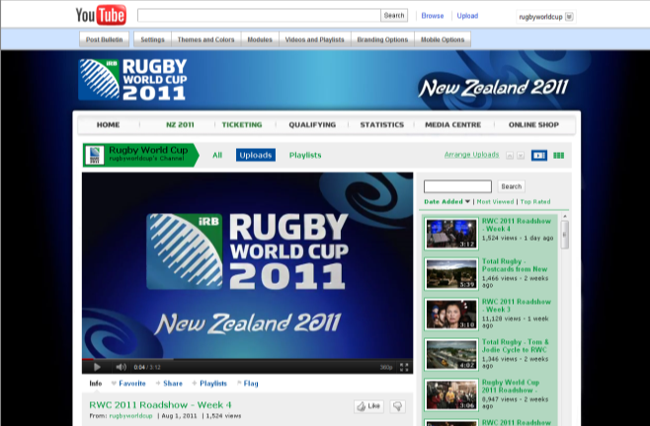
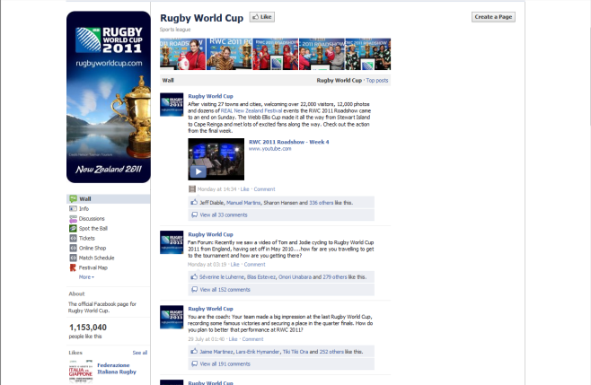
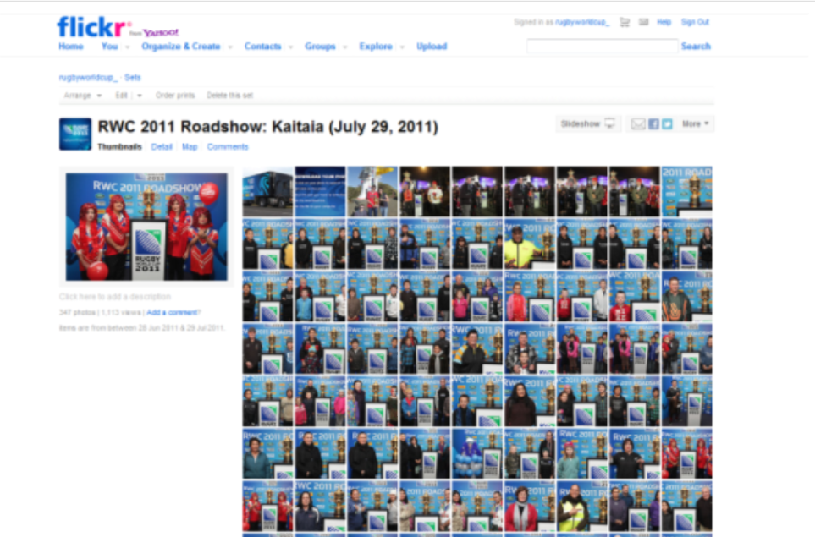
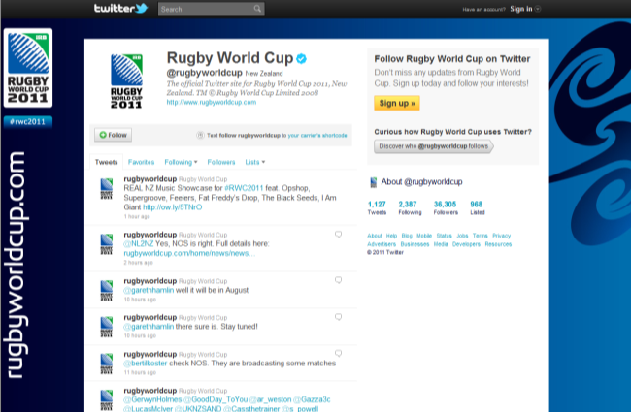

Style and voice
Writing for social media is very different from writing for print or even the general Web. Most social platforms limit the number of characters you can use in an update, so you need to pick your words wisely and use links to other information sources. See Appendix D for some guidelines on writing for social media to maximise your audience engagement.

A big component of an organisation’s online brand is its social media voice. With social media you have an opportunity to drop the corporate persona and create a more relaxed and informal communications voice.

  - How can you write you content to generate discussion and invite feedback?
  - How can you answer some of your fans’ most common questions?
  - How can you encourage your followers to build a strong community?
  - How can you write content in a more informal tone?

Step 7: Implementation

Now that you have figured out what is going on in your environment, what resources you have available, who you are trying to connect with, what you want to achieve, which platforms you are going to use and which tactics you are going to employ, start thinking about the actual roll out of your social media plan.

Timing
You do not have to launch all of your social media platforms at once. Sometimes it is better to do one thing well than spread your resources too thinly across too many platforms. If you feel confident with one platform, start slowly, commit fully and learn from your experience.

You should expect growth to be slow and a little awkward at first. People will not start engaging with you immediately - they need time to build trust and understand what you are all about.

Content management
Social media can be a tricky balancing act, coordinating different types of content (or the same content in different forms) across multiple platforms.

To help you plan out your content, try setting up a spreadsheet as shown in Appendix A. First of all, plug in any known milestones, events, launches or important news. You can then build your content plan, adding other types of content (messages, videos, photos, stories, etc) as it comes to hand.

  - How will social media content tie in with your other content, milestones, events and announcements?
  - Do we have a good mixture of shared and original content (60:40)?
  - Where can we source relevant content from?
  - Are all parts of the business represented in our content?

Note: You do need to be flexible, so be prepared to change things around if a great piece of news comes up. This tool will also help you keep track of the engagement levels and over time you will see which content is most effective.

Trial and error
Social media does take a while to get the hang of, and to cultivate an active audience, gain trust and getting your fans to interact with you and your content. You will not see instant results but don’t get discouraged!

In terms of your content, there is a certain amount of trial and error in learning what your audience does and doesn’t like. Why not ask them? Get them involved in shaping your content by asking them directly what they’d like to see.

Moderation
Unfortunately, not everyone behaves themselves when using social media and you will often come across unsuitable comments or content. It is important to agree internally what your policy will be to deal with inappropriate material. See Appendix B for a sample moderation policy.

Questions for you
  - Who will check information before it is published?
  - Who will be responsible for reviewing the page?
  - How regularly will they monitor the page?
  - What behaviour will your organisation not tolerate and why?

Note: Once you have established your moderation policy, be sure to let your social media followers know the boundaries (this may be on the profile or info section of the platform).

Awareness
Think of all the opportunities you have to promote your new platforms so your audience can get involved.

  - Are links to your social media platforms prominent on your website homepage?
  - Which of your stakeholders (partners, sponsors, athletes, events, venues etc) can help promote you on social media?
  - Which existing tools can you use to let people know about your sites? For example, your website, media release, newsletter, database and promotional materials.
  - How can you incorporate social messages into offline communications activities such as conferences, events, fora, etc?

For example, see the prominent links to social media on the Rugby World Cup 2011 homepage (www.rugbyworldcup.com)
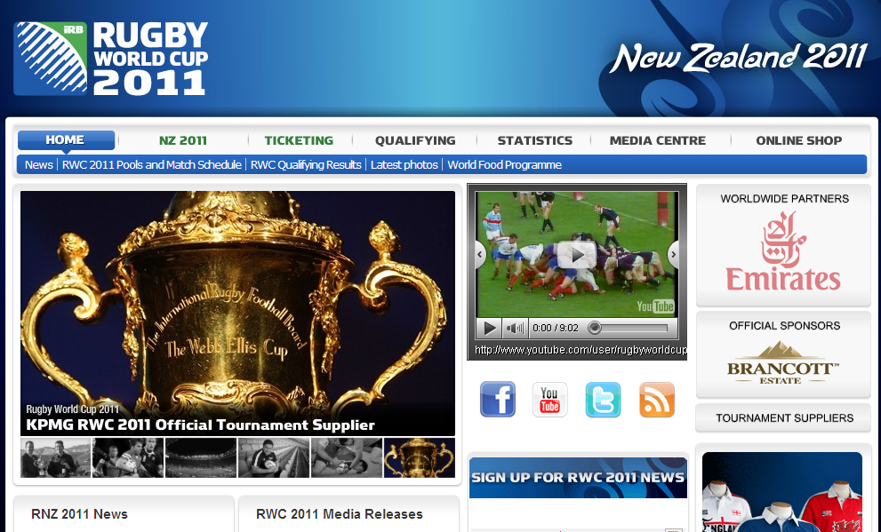

Step 8: Watch and learn

Monitoring
Compared with traditional media, social media can be relatively easy to measure. You should aim to develop an evaluation method that matches your objectives. Prepare in advance what you will measure, how often and with what tools.

Below is a summary of some of the key tools you may want to consider for managing your social media platforms and gaining valuable analytics to track your progress:

Google Analytics (www.google.com/analytics)
  - Your website may provide a good analytics tool, but if not there are a range of free analytics (“web stats”) tools to track traffic to and within your website. In the context of social media, you would use analytics to see how many people have been referred to your site from social media platforms.
  - The popular Google Analytics (“GA”) tool is free to set up and easy to use.
  - You can use GA to monitor your website traffic numbers, most popular pages, top search terms, sources of traffic and audience demographics.
  - Use the dashboard or create custom email reports.

Facebook Insights (www.facebook.com)
  - All Facebook brand pages receive a free “Insights Dashboard”, an analytics tool updated daily in US time (meaning a 24-hour delay for New Zealand statistics).
  - Insights shows page growth information such as new likes, lifetime likes, monthly and daily active users.
  - Provides key demographic information on page users (age, gender, language, country, city), important for understanding your audience.
  - Helps monitor effectiveness of each post in gaining feedback (likes, comments, shares).
  - For more detail on measurements available, please visit Facebook Help.

Twitter Metrics (www.twitter.com)
  - For verified Twitter accounts, Twitter provides a free analytics tool with follower demographic information (age, gender, city, country).
  - Unfortunately, Twitter verification (shown by a blue tick) is generally only available to companies who invest in advertising.
  - Also records engagement per post (retweets, favourites, click-throughs) to show how effective each piece of content is.

Hootsuite (www.hootsuite.com)
  - A free web and mobile application to monitor multiple feeds and searches
  - Includes multiple accounts from Twitter, Facebook, LinkedIn, Foursquare, PingFM, MySpace, Wordpress and Mixi.
  - The most popular free tool on the market, used by over 3 million people.
  - The free version includes “Quick Analytics”, showing click numbers, regions, referrers and most popular links.
  - A Hootsuite Pro account (US$5.99/month) gives additional analytics, custom reporting options and multiple administrators.
- Similar tools include TweetDeck (www.tweetdeck.com) and Seesmic (www.seesmic.com).

Radian6 (www.radian6.com)
- One of the most advanced tools on the market and available only by subscription, starting at AU$825/month.
- A very complex tool to help filter all conversations taking place around your brand using keywords, find influential users and monitor sentiment.
- Similar products include Sprout Social (www.sproutsocial.com), Collective Intellect (www.collectiveintellect.com) and ViralHeat (www.viralheat.com).
- If you already invest in media monitoring, some companies now also provide online and social media analytics as an add-on option.
- For a list of other paid tools, please visit Top 20 social media monitoring vendors for business.

Tweetstats (www.tweetstats.com)
- No sign-in required. Simply enter a Twitter handle to check basic stats or those of any other account.
- Only basic statistics provided include tweets per day, replies, retweets, keywords, and follower count.
- Similar Twitter-specific tools include SocialBro (www.socialbro.com) which requires an account and Twitalyzer (www.twitalyzer.com) which has subscriptions starting from $US4.99/month.
Klout (www.klout.com)
- Measures your influence (ability to drive action) on your Facebook, Twitter and LinkedIn networks.
- Gives a score out of 100 (average is 20) which ranks you against other users. By monitoring over time you can measure the effectiveness of your tactics.
- Other similar tools include PeerIndex (www.peerindex.com) and CrowdBooster (www.crowdbooster.com).

Note: It is important to note that not all benefits of social media can be quantitatively measured (sentiment, brand perception etc). Therefore the best insights come from a combination of measurement tools and an intrinsic understanding of your audience and content.

Step 9: Refine and improve

Social media is constantly evolving and changing, with new tools and ongoing modifications to existing tools. Once you are committed to a social media strategy, you will need to be flexible to allow for change.

Flexibility
Social media is an ongoing learning process as you get to know your audience and adapt your activities to best meet their needs. You should spend a large proportion of your social media time listening to your audience, tracking metrics and learning.

Questions or you
  - What is the best time of day to get the most engagement?
  - What types of content get the best engagement with fans?
  - Are you providing a good mixture of media types (photo, video, links)?
  - What content consistently falls flat?
  - What content tends to elicit negative responses?
  - Are you following up quickly enough?
  - Are you encouraging fans enough to talk to you?

Stay up to date
There are a number of industry resources, forums, blogs etc that you can tap into to stay up to date with significant industry changes. Below is a list of sources you may be interested in following (including via your social media platform):

- Mashable (www.mashable.com): Mashable is probably the largest community of social media professionals, with round-the-clock updates on the latest trends and tools.
- Social Media Today (www.socialmediatoday.com): Features contributions from a range of experts across a variety of social media tools. Sign up to the daily newsletter for a summary of the most topical blogs.
- Mari Smith (www.marismith.com): Mari provides practical updates and tips on new social media developments. Her webinars and “experimentation” of new social tools are particularly helpful.
- Social Media NZ (www.socialmedianz.com): A team of passionate social media gurus who bring you the best of social media in NZ. Check out their monthly video blogs “the Social Life” for some great case studies.
- Twitter: The keyword search feature of Twitter is a valuable tool for keeping up to date with the latest news in your industry. Using any number of Twitter aggregators (HootSuite, TweetDeck) set up search terms and hashtags feeds. It may help to group specific topics into separate feeds e.g. social media in sports hashtags are #sportsbiz, #smsports.

- Conferences: There are a range of conferences both on social media in general and its use in sport, which may help you share knowledge and learn from other sports doing it well.

Note: New social media tools come into the market all the time. While it’s important to keep up to date, don’t be tempted to jump on board the bandwagon of the latest tool without going through a thorough assessment (steps 1-6) to ensure the new tool will adequately meet a need in your organisation.

Checklist

□ Have you conducted a thorough analysis of your internal and external environment?
□ Are you clear about the different audience groups that may connect with your social media channels?
□ Have you reviewed the resources you have available (or may require) to commit to a social media plan?
□ Have you identified what goals you what you want to achieve with social media and how these contribute to your wider business objectives?
□ Are you familiar with the different types of social media and how they connect with different audiences?
□ Are you regularly monitoring what people are saying about your sport via social media?
□ Have you identified a range of content that your audience will be interested in hearing about and discussing?
□ Have you selected social media platforms that fit with your organisation’s business objectives?
□ Is your organisation committed to regularly updating and engaging with your audience to develop stronger relationships?
□ Have you developed a moderation plan for your organisation, specifying who will check your platforms, how often and what you won’t tolerate?
□ Have you developed a staff social media policy to inform your staff about the appropriate use of social media in your organisation?
□ Have you decided how you will roll out the implementation of your social media plan (single platform, multiple platforms, staggered launch)?
□ Have you identified opportunities to promote your new social media platforms and get people connected (for example, website, newsletters, partners, events, etc)?
□ Have you selected key metrics to monitor your audience and content in order to improve and measure your social media investment?
□ Are you committed to constantly reviewing and assessing your social media activities and learning from both your successes and your mistakes?
□ Do you have permission from senior management and marketing/communications to progress?
Appendix A: Sample Social Media Content Plan

NB. Content is a sample only

Date | Content | Website | Facebook | Likes | Comment | Shares | Talking about | Twitter | RT | Mentions | YouTube | Views | LinkedIn | LinkedIn comment
20-Jul | New coaching resource | Release | Post | 78 | 16 | 7 | 236 | Tweet | 8 | 4 |  |  | Post | 8
21-Jul | Poll question |  | Poll | 89 | 4 | 5 | 546 | Tweet | 2 | 6
22-Jul | Newsletter | Article | Post | 28 | 12 | 2 | 465 | Tweet | 6 | 4 |  |  | Post | 4
23-Jul | Video interview |  | Post | 57 | 14 | 6 | 365 | Tweet | 6 | 6 | Video | 107
24-Jul | Athlete of the month |  | Poll | 89 | 3 | 4 | 276 | Tweet | 5 | 7
25-Jul | News article |  | Post | 142 | 18 | 7 | 521 | Tweet | 13 | 2
26-Jul
27-Jul | Quote from athlete |  | Post | 88 | 45 | 7 | 297 | Tweet | 9 | 3
28-Jul | Latest research released |  | Post |  |  |  |  | Tweet |  |  |  |  | Post
29-Jul | TBA |  | Post |  |  |  |  | Tweet
30-Jul | CEO column |  | Post |  |  |  |  | Tweet |  |  |  |  | Post
31-Jul | NZOC athlete blog | Article | Post |  |  |  |  | Tweet
1-Aug
2-Aug
3-Aug | TBA (news from weekend) |  | Post |  |  |  |  | Tweet
4-Aug | Athletics Champs begin | Article | Poll |  |  |  |  | Tweet |  |  |  |  | Post
5-Aug | Athletics Champs photos |  | Photos |  |  |  |  | Tweet
6-Aug | Athletics Champs results |  | Results |  |  |  |  | Tweet |  |  | Video
7-Aug | Guest athlete questions |  | Post |  |  |  |  | Tweet
8-Aug

Appendix B: Sample moderation policy

Moderation
The open nature of social media may see you may receive negative posts and criticisms. Because it is important to preserve openness and a sense of free expression, censorship should be kept to a minimum.

Whenever possible, resist the temptation to simply remove critical and otherwise negative posts. Instead, respond to legitimate criticism if appropriate.

Sample policy
Where possible, you should have on your platform a statement clearly articulating your moderation or terms of service policy. See the example below.

While we welcome your participation on this site, please do not post any content containing offensive language, racial/sexist slurs, personal insults, spam or material in violation of any law. Any posts in breach of these standards will be removed within 24 hours. Repeat offenders may be blocked from participating in the community.

Tolerance Level
Your organisation should collectively establish a tolerance level for user-generated content to determine what content will and won’t be removed. This includes the organisation’s definition of spam, offensive language or personal insult.

Crisis management
Social media, in particular Facebook and Twitter, provides a valuable means of monitoring and tracking the external environment. As such it can be a good early warning system for any issues that emerge.

Social media allows you to prioritise what is important based on what your customers are reacting to. To avoid rumours or misinformation it is important to deal with issues as promptly as possible.

As with your regular communications work, prepare in advance for any issues and what your response will be.
- Who needs to be informed?
- Who is authorised to reply?
- What are the key messages?

Appendix C: Sample staff social media policy

[Organisation] Social media policy

Introduction to organisation

We recognise the importance of online conversations and respect the right of all employees to freedom of speech. However, there are some basic principles of behaviour that we ask all employees to respect when conducting online activities.

This policy is designed to document those principles and guide your participation in both personal and professional usage.

Official Use

Authorisation
- Participation via the official mass communications platforms (Facebook, Twitter or YouTube) should only come via [relevant team for position]. Official activity will be published under the [organisation] brand.
- If you wish to establish or participate in any other form of official [organisation] social media, eg a Facebook page or group, a new Twitter account etc, please discuss this with the social media manager prior to acting.

Representing [organisation]
- As a [organisation] employee you may be invited to participate in internal sector social networks in a professional capacity (LinkedIn, Yammer) which you may do under your own name.
- You should only comment on areas of work that are within your area of professional responsibility.
- The content and opinions you share should be consistent with the values of [organisation] and our professional standards.
Personal use

Nothing is private
- Remember that publishing on a personal social media platform is as good as talking to the media. You cannot control what happens to your content once it is published, even if you modify or delete it.

Identify yourself
- It is important that you do not post information or opinions that could be interpreted as an official opinion or statement on behalf of [organisation] unless you have prior permission from [relevant team for position].
- When using social media as an individual you should identify your views as your own and not those of your employer.

Be a good [organisation] ambassador
- No matter what level you are working at, when using social media either in a personal or professional capacity, you are an ambassador for [organisation]. Don’t publish anything you wouldn’t want your boss to read or see.

Maintain a high standard
- Before posting any content check your facts are accurate, fair, credible
- Check spelling and grammar. It’s best to craft a response in a Word document, then paste into the social media platform.
- If you make a mistake in a post, it’s best to confess. It is almost impossible to delete something from social media once it has been published.

Be polite and professional
- At all times be polite, pleasant, respectful and professional. Sitting behind a computer screen is no excuse for discourtesy. Note that humour can be misinterpreted online.

Be on to it
- Respond to questions in a timely manner. The quicker the response, the more likely the conversation will continue to build. Make sure you check your sites regularly. An out-of-date account with unanswered posts looks bad.

Respect privacy, copyright and other legal rights
- Never give out personal details, confidential information or other content you don’t have permission to publish (budget, internal policies or documents, intellectual property, etc). Employees who share confidential information do so at the risk of disciplinary action or termination.

Respect the [organisation] brand
- Please do not use the [organisation] logo or any other trademarked marks or images on personal social media sites.
- Do not use the [organisation] name or brand to promote a product, service, cause or opinion.

Time allocation
- Staff have permission to monitor social media sites in work hours for business purposes. Set aside some time twice a day to review and respond. The golden rule is that it should not interfere with getting your work done.
- When accessing social media at work, your usage is subject to existing ICT Security and ICT Usage policies.

If you have any doubts, take advice from your manager or the Marketing and Communications team or don’t post it!

Appendix D: Writing for social media

Social media is based on short, catchy and engaging bites of information. With a limited number of characters (140 characters on Twitter and 5,000 on Facebook), how can you ensure your content will hit the mark?

Checklist
□ Am I a nominated social media administrator?
□ Do I need permission to publish this from the author or within the organisation?
□ Is this content relevant to my wider audience?
□ Is this content recent/timely?
□ Is it a good time of day to publish? (Research shows best time is 11am-3pm.)
□ How can I write this to encourage a response, discussion or conversation?
□ Does the post get straight to the point?
□ Can I cut any unnecessary words?
□ What other links can I use to connect?
- @ mentions = other Twitter users
- Facebook pages = other individuals or organisation pages
- Hashtags = relevant topics or trends
□ Is this post consistent with our style guide and social media voice (ie, not too formal)?
□ Have I included my keywords to increase search rankings?
□ Are there spelling or grammatical errors?
□ What questions do I expect to receive about this post?
□ Am I available to provide further information if requested?

Example
In this example, we take a NZ Herald article and illustrate how we’d feature it on Facebook and Twitter.

NZ Herald article: “Teenager throws record shot put to qualify for London Olympics”

Facebook: Kiwi teenager Jacko Gill [link to Facebook page] has achieved qualification for the London 2012 [link to Facebook page] Olympic Games with a record shot put throw of 22.08m. This will make him the youngest competitor in his field. Did you see his record-breaking throw? > Link to article with image/video

Twitter: Kiwi teenager @JackoGill has qualified for #london2012 with a record shot put throw of 22.08m bit.ly/XXXXXX #olympic #nzolympic #sportnz

Appendix E: Athlete use of social media

Athlete content
Athletes are one of your best sources of social media content. In fact some of the users with the largest followings are athletes: @KAKA, @Cristiano, @shaq @KingJames and@lancearmstrong all feature in the top 100 Twitter users.

Athletes have access to the front line of sport and the fans want to hear (and see) all about it. It is also a great opportunity to raise the profile of your elite athletes and help them connect with fans of the sport.

Twitter’s “Twitter for Athletes” gives many examples of the effective use of social media by athletes.

Athlete education
It is important to know which of your athletes are using social media. You will want to regularly monitor their accounts, both as a source of good content and to ensure they are using the platforms as good ambassadors for your sport.

It is also a good idea to work closely with your athletes to educate them about social media etiquette. This might be done through a guidelines or policy document or in a face-to-face workshop or video conference.

Many sporting teams, events and leagues balance encouraging athletes to use social media with the application of clear social media guidelines. For example, some organisations enforce social media blackouts on game days and require athletes to be aware of sponsor obligations.

Useful resources

- Twitter for Athletes
- London 2012 Olympic Games Social Media Guidelines
- London 2012 Paralympic Games Social Media Guidelines
- The 100 Twitter rules to live by
- Social Media rules for athletes
- Guide to leagues' social media policies
- 50 Twitter Tips for Division I Student-Athletes

Appendix F: Social Media Glossary

Facebook

Status A short message (maximum 5,000 characters) to inform others of your actions and thoughts.
Newsfeed The ongoing list of updates on your home page that shows you what's new with the friends and pages you follow.
Ticker Small box in the top right hand corner of all pages which shows all updates in chronological order.
Wall The main page of a profile or page where all posts appear (now in the form of a timeline).
Tag A link to another Facebook user via an update, photo or video (tagged information will appear in their timeline).
Chat Type real-time messages between two friends within Facebook (not visible to others).
Like Shows support for a post by giving it a thumbs up (will appear in the ticker). Also allows a user to connect with a page via a “like” button, often placed on a website page.
Comment When a user adds additional text in the section below the original post (will appear in the ticker).
Share To republish an update on your own profile (will appear in your news feed and ticker).
Profile A personal Facebook page for an individual user which compiles all your published information.
Page A page for a business, brand, and celebrity. Pages can be managed by multiple administrators and provide analytics on users and content.
Group Groups are close circles of people that share and keep in touch on Facebook. Can have restricted (request only) or open membership.
Place A Facebook page for a physical location (eg, a town, business or venue). Allows users to “check in” when they visit.

Twitter

Tweet A short message of no more than 140 characters. Also used as a verb (“I tweeted it”).
Timeline A list of all the tweets sent by the users that you follow. Listed in chronological order.
Follow To subscribe to another users’ tweets. You can also “unfollow” a user to no longer receive their tweets.
Username Also known as a Twitter handle. Must be unique and contain fewer than 15 characters.
@ Used in front of a username to link to another Twitter user (“Hello @sportnz”).
Hashtag A word or phrase preceded by the “#” symbol and used to group topics e.g. #worldcup.
Mention Mentioning another user in your tweet by including the “@” sign followed directly by their username.
DM (Direct Message.) A private message of 160 characters or less sent from one Twitter user to another.
Reply A tweet posted in reply to another user's message. Always begins with @username.
RT (Retweet) The act of forwarding another user's tweet to all of your followers.
List A collection of Twitter accounts manually compiled by a user around a theme or topic. Can be shared or private.

Google+

Circle A way to categorise your friends and followers which allows you to control who sees what content.
Stream The main page of Google+ showing updates from your friends and pages you are connected with. Shown in chronological order.
+1 A way to publicly recommend content via the +1 button found in Google or on certain pages (you can choose to share this in your stream or with certain circles). This is similar to Facebook’s “like” button.
Hangout A group chat tool for use by members of your circle including video, text and voice. Can support up to ten users at a time.

The following table shows how terminology is used across the three platforms. Terms on each row are more or less equivalent.
Facebook | Twitter | Google+
What's on your mind? | What’s happening? | Share what’s new…
Comment | Reply | Comment
Like | Favorite | +1
Share | Retweet | Share
Friend List | Following/Followers | Circles
Friends of Friends | n/a | Extended Circles
News Feed | Timeline | Stream
Chat | n/a | Chat
n/a | n/a | Hangouts
Tag | Mention | Mention
Notifications | n/a | Notifications
n/a | Hashtags | n/a

YouTube

Like Users can vote on videos with the like or unlike buttons which affects the video’s rating.
Views The number of times each video has been viewed. May come from within YouTube or via external sites (hits on videos embedded in websites or other social platforms)
Stream Video played in real time, as it is transmitted.
Comment Users may post written feedback on a particular video or channel.

Sources: Media Bistro, Genius Geeks, YouTube Glossary, Facebook Help Centre. See References, below, for details.

References

Business Balls, Free SWOT analysis template, http://www.businessballs.com/swotanalysisfreetemplate.htm, accessed 20 December 2011.
Social Media Examiner, Social Media Marketing Industry Report 2011, http://www.socialmediaexaminer.com/social-media-marketing-industry-report-2011/, accessed 14 December 2011.
Ron Jones, 6 Steps in Developing a Social Media Strategy, http://www.clickz.com/clickz/column/2046657/steps-developing-social-media-strategy, accessed 24 November 2011.
Social Media Examiner, Social Media Marketing Industry Report 2011, http://www.socialmediaexaminer.com/social-media-marketing-industry-report-2011/, accessed 14 December 2011.
Outthink Group, The 6 types of social media, http://outthinkgroup.com/tips/the-6-types-of-social-media, accessed 24 January 2012.
Wikipedia, Social Bookmarking, http://en.wikipedia.org/wiki/Social_bookmarking, accessed 24 January 2012.
New Zealand Department of Internal Affairs, Social Media in Government: Hands-on Toolbox http://webstandards.govt.nz/guides/strategy-and-operations/social-media/hands-on-toolbox/, accessed 11 January 2012.
About.com Web Trends, Daniel Nations, How to Get Started with Social News, http://webtrends.about.com/od/socialbookmarking/a/socialnews_how.htm, accessed 26 January 2012.
WIkipedia, Blogs, http://en.wikipedia.org/wiki/Blog, accessed 24 January 2012.
Nonprofit Quarterly, Four reasons why not to use social media and why to use it anyway, http://www.nonprofitquarterly.org/index.php?option=com_content&view=article&id=18531:four-reasons-why-not-to-use-social-media-and-why-to-use-it-anyway&catid=153:features&Itemid=336, accessed 21 December 2011.
Nick Usborne, 10 ways in which social media writing is different from traditional web writing, http://www.webcontentcafe.com/2010/10/10-ways-in-which-social-media-writing-is-different-from-traditional-web-writing/#axzz1j0xYxBDf, accessed 10 January 2012.
Twitter Counter, The top 100 most followed on Twitter, http://twittercounter.com/pages/100, accessed 23 January 2012.
Twitter, Twitter for Athletes, https://dev.twitter.com/media/twitter-for-athletes, Accessed 25 November 2011.
Twitter, Twitter for Athletes, https://dev.twitter.com/media/twitter-for-athletes, Accessed 25 November 2011.
International Olympic Committee, IOC Social Media, Blogging and Internet Guidelines for participants and other accredited persons at the London 2012 Olympic Games, http://www.olympic.org/Documents/Games_London_2012/IOC_Social_Media_Blogging_and_Internet_Guidelines-London.pdf, accessed 22 January 2012.
International Paralympic Committee, IPC Social Media Guidelines for Persons Accredited at the London 2012 Paralympic Games, http://www.paralympic.org/export/sites/default/Paralympic_Games/London_2012/2011_11_24_IPC_Social_Media_Guidelines_FINAL_update.pdf, accessed 22 January 2012.
CNBC, “The 100 Twitter rules to live by”, http://www.cnbc.com/id/43759244/The_100_Twitter_Rules_To_Live_By/print/1/displaymode/1098/ accessed 25 November 2011
Search Engine Watch, Kaila Strong, Social Media Rules for Athletes, http://searchenginewatch.com/article/2083098/Social-Media-Rules-for-Athletes, accessed 22 January 2012.
ESPN, Maria Burns Ortiz, Guide to leagues’ social media policies, http://espn.go.com/espn/page2/story/_/id/7026246/examining-sports-leagues-social-media-policies-offenders, accessed 22 January 2012.
Conspicuous Ideas, Tom Satkowiak, Twitter tips for Division 1 Student-Athletes, http://conspicuousideas.blogspot.com/2011/07/50-twitter-tips-for-division-i-student.html, accessed 22 January 2012.
Dain Binder's Technology Blog, Google+ Terms and Translations, http://www.dainbinder.com/2011/07/google-terms-and-translations.html, accessed 26 January 2012.

