Recognising and classifying injuries
Sports injuries may be classified in relation to the type of tissues injured, e.g. soft tissues (muscle, skin) or hard tissues (bone). More often, sports injuries are classified in relation to their cause. The main types are primary, secondary, direct, indirect and chronic injury.
Primary injury
Occurs directly as a result of a sporting activity.
Secondary injury
- Occurs as a result of an earlier injury, which may have been treated inadequately, if at all.
- May occur when an athlete returns to training and/or competition before a previous injury has healed fully.
Direct injury
- Occurs as a result of an outside cause such as an external blow or extreme force applied to the body.
- Frequently the most immediate and severe type of injury.
- More than one type of tissue can be damaged in the one incident. For example, a dislocation (e.g. shoulder) can involve muscles, tendons, ligaments and nerves; a severe, sudden impact with the ground in a fall, with another athlete, or with sports equipment, can produce internal bleeding, with or without fractures.
- Be aware that protective gear has limitations: shoulder pads will protect a rugby player from bruising but not from fractures or dislocations; knee pads will not reduce the incidence of internal injury to the knee tissues. Athletes must be made aware of such limits, and not be lulled into a false sense of security.
- SHOCK must be considered seriously, and must be treated in such cases.
Indirect injury
- Usually occurs as a result of the individual’s over-estimation of their body’s capabilities.
- Many of these types of injuries may be prevented by attending to fitness (overall, pre-season, in-season, off-season), preparation (suitable clothing and equipment, warm up, stretching, warm down) and technique (use of correct techniques).
Chronic injury
- Occurs as a result of overuse.
- May be the result of inappropriate use of the body, which places excessive stress on particular tissues, e.g. bones, ligaments, and other soft tissues.
- Poor training programmes cause the majority of chronic injuries.
- May be caused by poor technique, which increases the load placed on some structures e.g. poor backhand technique in tennis may overload structures that stabilise the elbow joint.
- Poor selection of equipment may exaggerate the stress placed on the body by poor technique e.g. a tennis racquet that is too heavy.
- Generally arise when there is a sudden change in the frequency or intensity of an activity for which the tissue is unprepared e.g. a marathon runner increasing weekly training distance too quickly.
- In children, may occur at the epiphysis plate i.e. that part of the bone where growth occurs. Symptoms: pain develops initially during, and then after exercise, and occasionally in bed at night. Common sites: upper end of the tibia, back of the heel bone, spine and upper end of the femur.
- Stresses are usually repetitive in nature and cause micro-damage to tissues, which under normal circumstances, are able to repair the damage naturally. If the stress continues and becomes excessive, the damage accumulates until it exceeds the body’s ability to repair itself naturally.
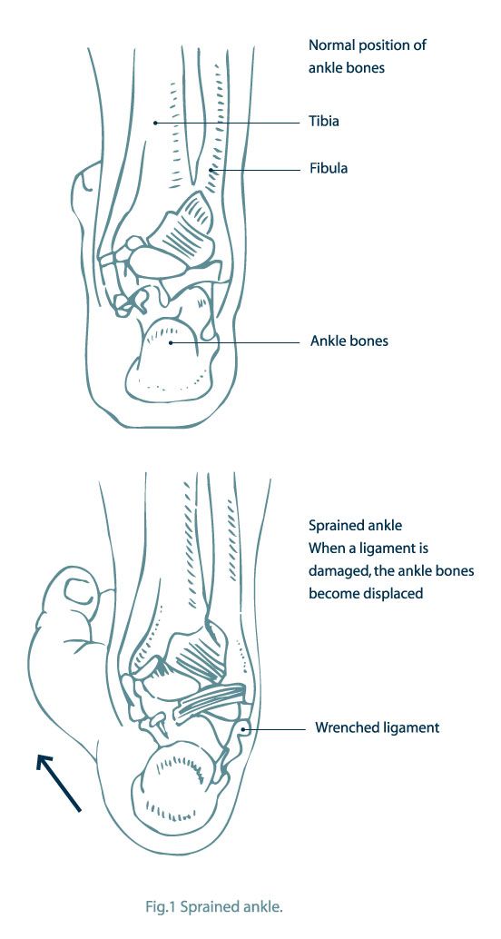
Soft tissue injuries
Soft tissue injuries (sprains and strains) are the most common sporting injuries.
Sprains
- Sprains are injuries to the ligaments.
- The more the ligaments are torn, the more severe the injury.
- Ligaments can rupture completely and/or dislocate the bones they attach to.
- Ligaments may be pulled away from their point of attachment, especially in young children.
- Fractures may also occur.
- Treat severe sprains as fractures.
- Not all symptoms will always be immediately apparent e.g. bruising.
- A mild sprain only stretches the ligament, with a brief period of pain only. The athlete is able to return to activity with little discomfort.
- Sprains are often not treated, and the joint is frequently re-injured i.e. they become chronic, indirect or secondary injuries.
Strains
- Strains are an injury to muscles and/or tendons.
- The more the muscle fibres are torn, the more severe the injury.
- Usually caused by over exertion, e.g. lifting something too heavy, working a muscle too hard, or a sudden uncoordinated movement.
- Not all symptoms will always be immediately apparent.
- Without immediate treatment and a sufficient rehabilitation period, strains may become chronic, particularly in the neck, lower back, and the back of the thigh.

Dislocation
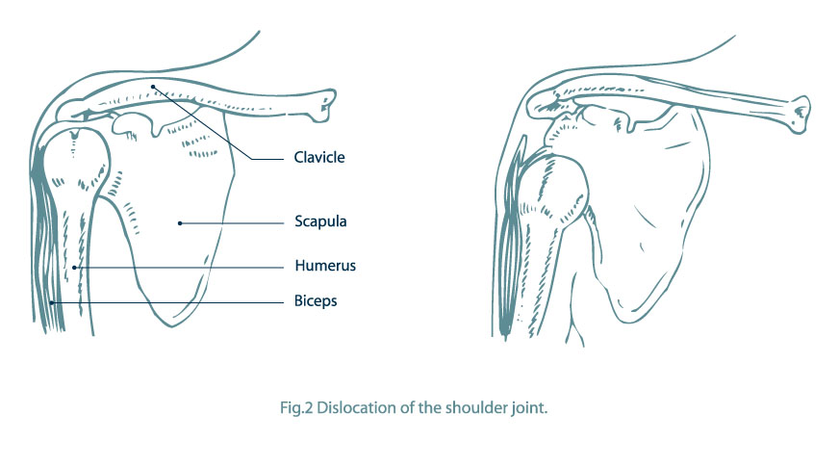
- Dislocations are an injury where one or more bones are completely displaced.
- They can cause fracture and damage to ligaments, tendons, blood vessels and nerves.
- They are generally more obvious than fractures because of deformities e.g. a lump, ridge or depression.
- Joints at the shoulder, thumb, fingers, and jaw dislocate more easily than others because there is a wide range of movement possible at these joints, and the bones, ligaments, and muscles do not provide a lot of protection to the joints.
- It may be impossible to distinguish a dislocation from a fracture, so treat it as a fracture.
Overuse injuries
- Pain develops gradually and is felt, initially, after exercise. If it is felt prior to exercise; it is usually relieved through warming up.
- If the problem continues, athletes begin to feel pain during and after activity, which is not relieved by warming up or by exercise.
- If the problem is still not treated, athletes will feel pain all the time, even when resting.
- Pain is, in all causes, accompanied by inflammation of the affected tissues.
- Tendons and muscle attachments to bone are commonly affected by overuse. Common sites are the elbow, wrist, shoulder, knee and shin area.
Concussion
- Not all signs and symptoms need to be present for concussion to have occurred.
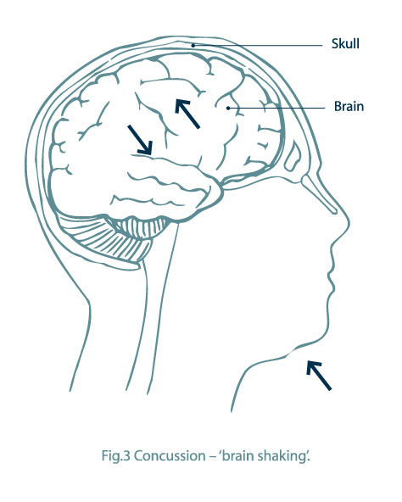
- Symptoms may mask other injuries e.g. skull fracture and compression.
- With any obvious facial or scalp injury e.g. bleeding, contusion or bruising, check for concussion.
- A skull fracture may be present without much evidence of external damage.
- Initial symptoms may be brief and recovery rapid. It is essential to seek professional assessment as signs can reappear anywhere between 6 and 48 hours later.
- The most important thing to remember about concussion is that it means the brain has been damaged.
- The severity of concussion is measured by two things:
  - the length of time there has been loss of consciousness
  - the length of time there has been memory loss.
Nose bleed
- A nose bleed is a much underestimated head injury.
- Often due to the rupture of blood vessels inside the nostrils.
- Can be caused by a blow to the nose, sneezing or blowing the nose.
- May be an indication of a head injury, so check for concussion.
- Look for watery-looking, blood-stained fluid; if present, suspect a skull fracture.
- Can cause considerable blood loss.
- May cause vomiting if blood is swallowed.
- Can affect breathing if blood is inhaled.
Black eye
- Usually caused by a blow over the orbit i.e. the eye socket.
- May be associated with an unnoticed concussion.
- Ruptured blood vessels will redden the white of the eye.
- Bruising of the facial tissue (e.g. eye lids) often begins as a deep reddening, and later becomes dark blue.
- If the surface of the eye ball appears flattened, the injury is serious. Immediate removal to a hospital, preferably one with an eye unit, is important.
- If the athlete has clouded vision or no vision, urgent medical assessment is needed.
Hard tissue injuries (fractures)
- There are a number of different types of fractures. They may be classified as simple or closed fractures, and compound or open fractures. In a compound or open fracture, the bone breaks the surface of the skin.
- When first examined, injuries may appear to be severe sprains rather than fractures. If in doubt, treat them as a fracture.
- Any fracture is accompanied by extensive soft tissue injury, involving bleeding and inflammation of the tissues. In severe cases, bone fragments may be forced into organs, causing additional damage. Open fractures may also become infected.
- Internal bleeding will attend closed/simple fractures. Internal and external bleeding will attend compound/open fractures.
- Shock will be a factor, and must be treated even if only as a precaution.

