Field event instructions
High jump
Hints on organising the high jump
- Enter names on the results sheet.
- Allow practice jumps at a height below the starting level.
- Explain rules if needed.
- Announce the starting height and subsequent height every time the bar is raised.
- Call the name of the next jumper and who will follow then. E.g. John Smith followed by Sam Jones.
- Measure new heights at the start of each round. Height should be taken from the middle of the bar. Height at each end of bar is slightly higher (about 1.5cm.) Each end should be the same height, e.g. left and right side both measure 1.36.5m, meaning height in middle of bar is 1.35m. This will be the jumping height: 1.35m.
- Each competitor gets up to three attempts at each height.
- A jumper is eliminated after three consecutive failures.
Important rules
It will be a failed attempt if you:
- knock the bar off, even if a landing is made before the bar falls
- have a two-foot take off
- touch the ground or apparatus beyond the uprights before jumping.
Starting heights
Grade | Girls | Boys
Junior (JNR) | 1.20m | 1.30m
Intermediate (INT) | 1.25m | 1.35m
Senior (SNR) | 1.30m | 1.40m

Starting heights are the heights of the high jump bar at the beginning of the event. The heights indicated here are for a central zone regional event, so schools may wish to lower this depending on how good their athletes are. A good height to start with is what you would expect 80% of your athletes to jump over. PE teachers who are teaching high jump would also have a good indication of a reasonable height to start at.
Heights go up 5cm between each round until there are around 3 competitors left. From there on the bar will be raised 3cm each time.
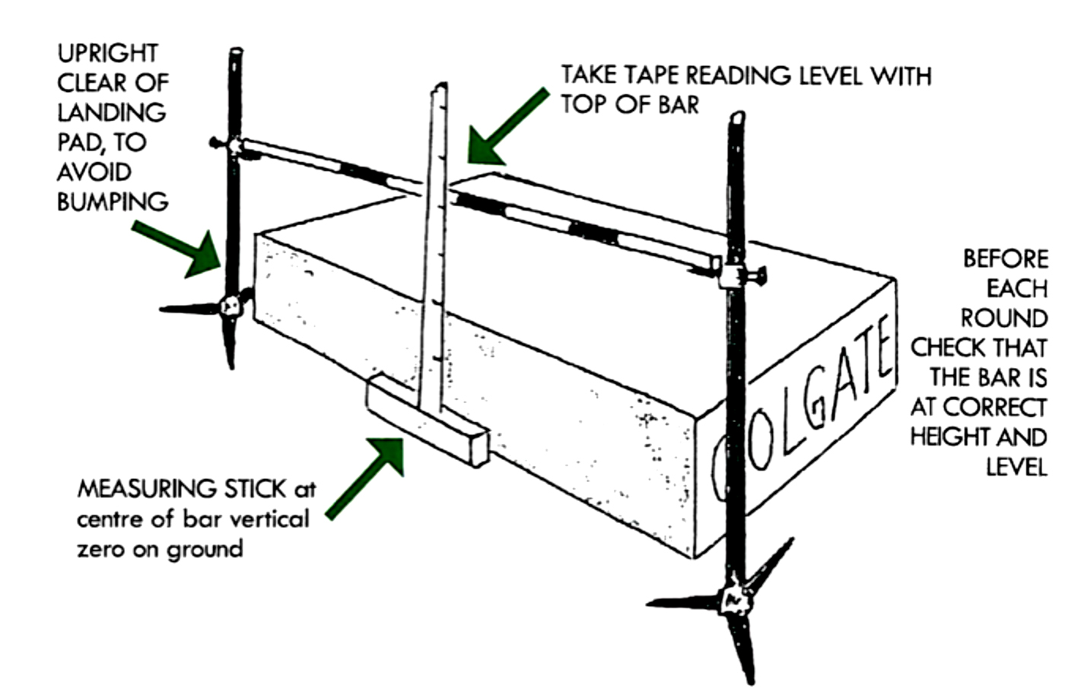

If a competitor leaves to go to a track event, when they return they will enter back in at the current height. The bar will not be lowered back down.
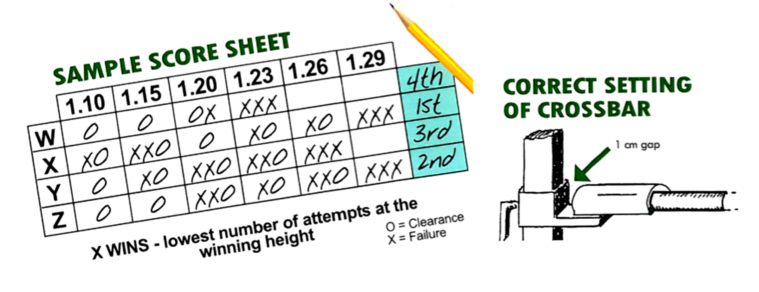

Count back rules
- The winner is the competitor with the lowest number of jumps at the winning height.
- If a tie remains, the winner is the competitor with the lowest number of failures throughout the event, including the last height cleared.
- If a tie still remains (for first place only), jump off as follows:
    - one more jump each at the last failed height
    - if still tying, the bar shall be raised or lowered 2cm as appropriate and each competitor may attempt one jump at each height.
Shot put
Hints for organising the shot put
- Record competitor’s name on the result sheet.
- Allow a practice if time permits.
- Briefly explain the rules.
- Call competitor’s name and who will follow after them. E.g. John Smith followed by Sam Jones. This allows the event to run efficiently and without delays.
- Specify the number of puts. (Three each then top 8 have an extra 3 if an appropriate standard has been reached).
- Safety is important, keep an eye on competitors and extra shot puts that may be around.
Important rules
- The shot put must be in contact with the neck through the action.
- It should not fall away from the neck and behind the shoulder.
- You must start from a stationary position inside the circle. (No running into the circle.)
- The competitor must not touch the ground outside the circle, nor the top of the stop board or circle ring. The inside of the ring and stop board may be touched though.
- The competitor must leave the circle from the rear half, but only after the shot has landed.
- On the line is out.
Secondary school weights
Junior girls 3.00kg Junior boys 4.00kg
Intermediate girls 3.00kg Intermediate boys 5.00kg
Senior girls 3.00kg Senior boys 5.00kg

Athletes with disabilities (AWD) Boys Girls
Wheelchair (AWDWC) 3kg 2kg
Intellectual (AWDID) 4kg 3kg
Cerebral palsy (AWDCP) 3kg 2kg
Amputee/other (AWDAMP/other) 4kg 3kg
Vision impairment (AWDVI) 4kg 3kg

Shot put | Qualifying distance¹ | Measurement distance²
JNR boys | 9.75m | 8.00m
JNR girls | 8.00m | 6.50m
INT boys | 11.50m | 9.50m
INT girls | 9.00m | 7.00m
SNR boys | 12.00m | 10.00m
SNR girls | 8.00m | 7.00m

- Qualifying distances are distances that have to be achieved for extra throws. If more than 8 competitors achieve this mark, only the top 8 will be awarded extra attempts.
- Measurement distances are the minimum distance that must be achieved to be measured. This will be marked out by officials
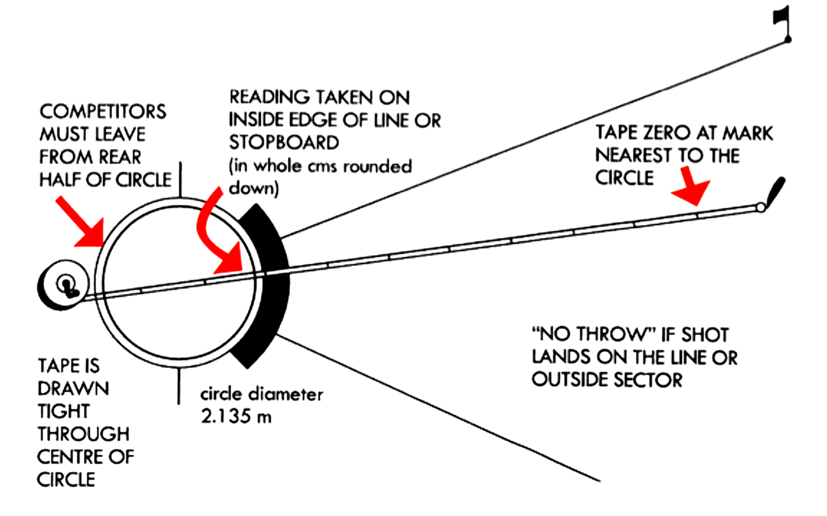

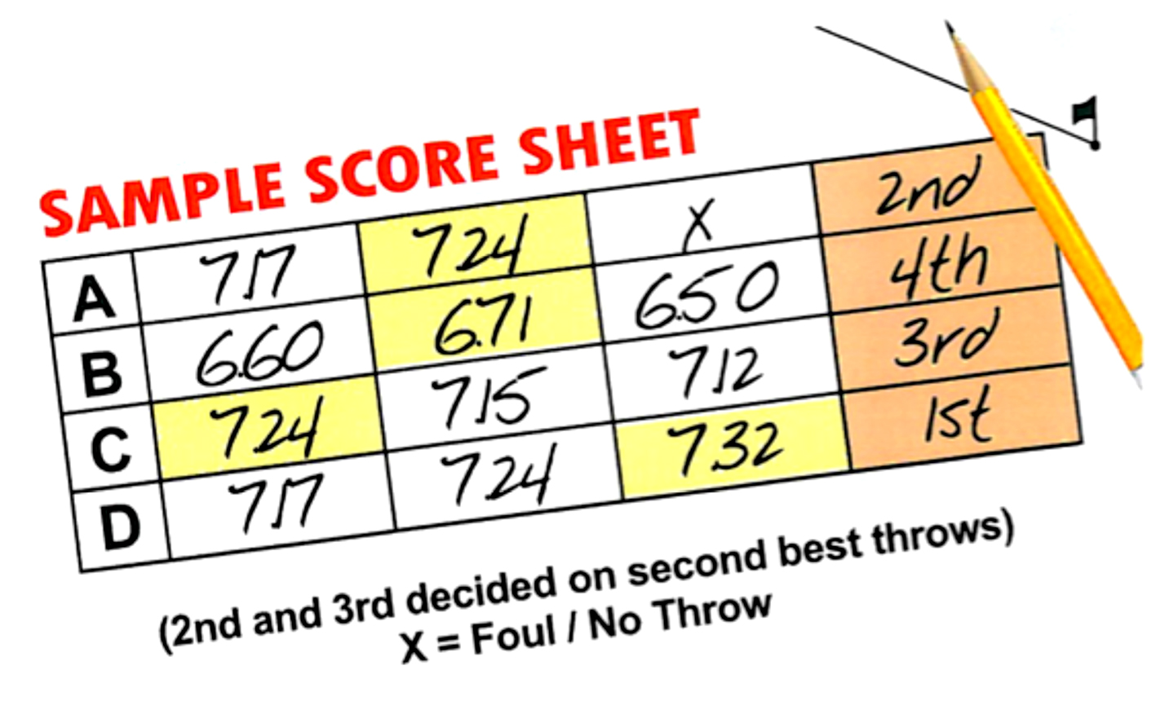
Discus
Hints on organising the discus
- Record competitor’s name on the result sheet.
- Allow a practice throw if time permits.
- Briefly explain the rules.
- Call competitor’s name and who will follow after them. E.g. John Smith followed by Sam Jones. This allows the event to run efficiently and without delays.
- Specify the number of throws. (Three throws each. The top 8 then have an extra 3 if an appropriate standard is reached.)
- Safety is very important, keep an eye on competitors. They should not be in front of the caged area, fingers off the netting and watching for miss guided throws.
Important rules
- The thrower must be stationary inside the circle before commencing their throw.
- The thrower must not touch the top of the circle ring, nor the ground outside the circle.
- The thrower must not leave the circle until the discus has landed.
- Once the discus has landed they must exit through the rear half of the circle.
- On the line is out.
Secondary school weights
JNR Girls 1kg JNR Boys 1kg
INT Girls 1kg INT Boys 1.25kg
SNR Girls 1kg SNR Boys 1.5kg

Boys Girls
Wheelchair (AWDWC) 750g 750g
Intellectual (AWDID) 1kg 1kg
Cerebral Palsy (AWDCP) 750g 750g
Amputee/other (AWDAMP/other) 1kg 1kg
Vision Impairment (AWDVI) 1kg 1kg

Discus | Qualifying distance¹ | Measurement distance²
JNR boys | 28.50m | 20.00m
JNR girls | 19.00m | 15.00m
INT boys | 32.00m | 23.00m
INT girls | 22.00m | 16.00m
SNR boys | 33.00m | 25.00m
SNR girls | 23.00m | 18.00m

- Qualifying distances are distances that have to be achieved for extra throws. If more than 8 competitors achieve this mark, only the top 8 will be awarded extra attempts.
- Measurement distances are the minimum distance that must be achieved to be measured. This will be marked out by officials

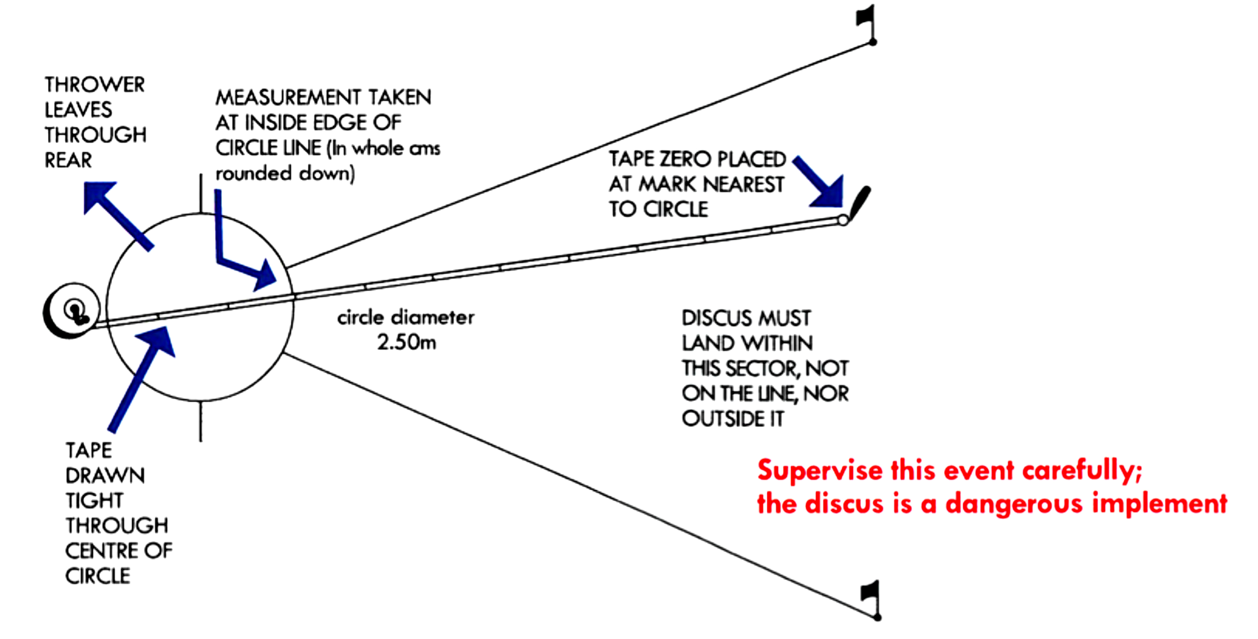
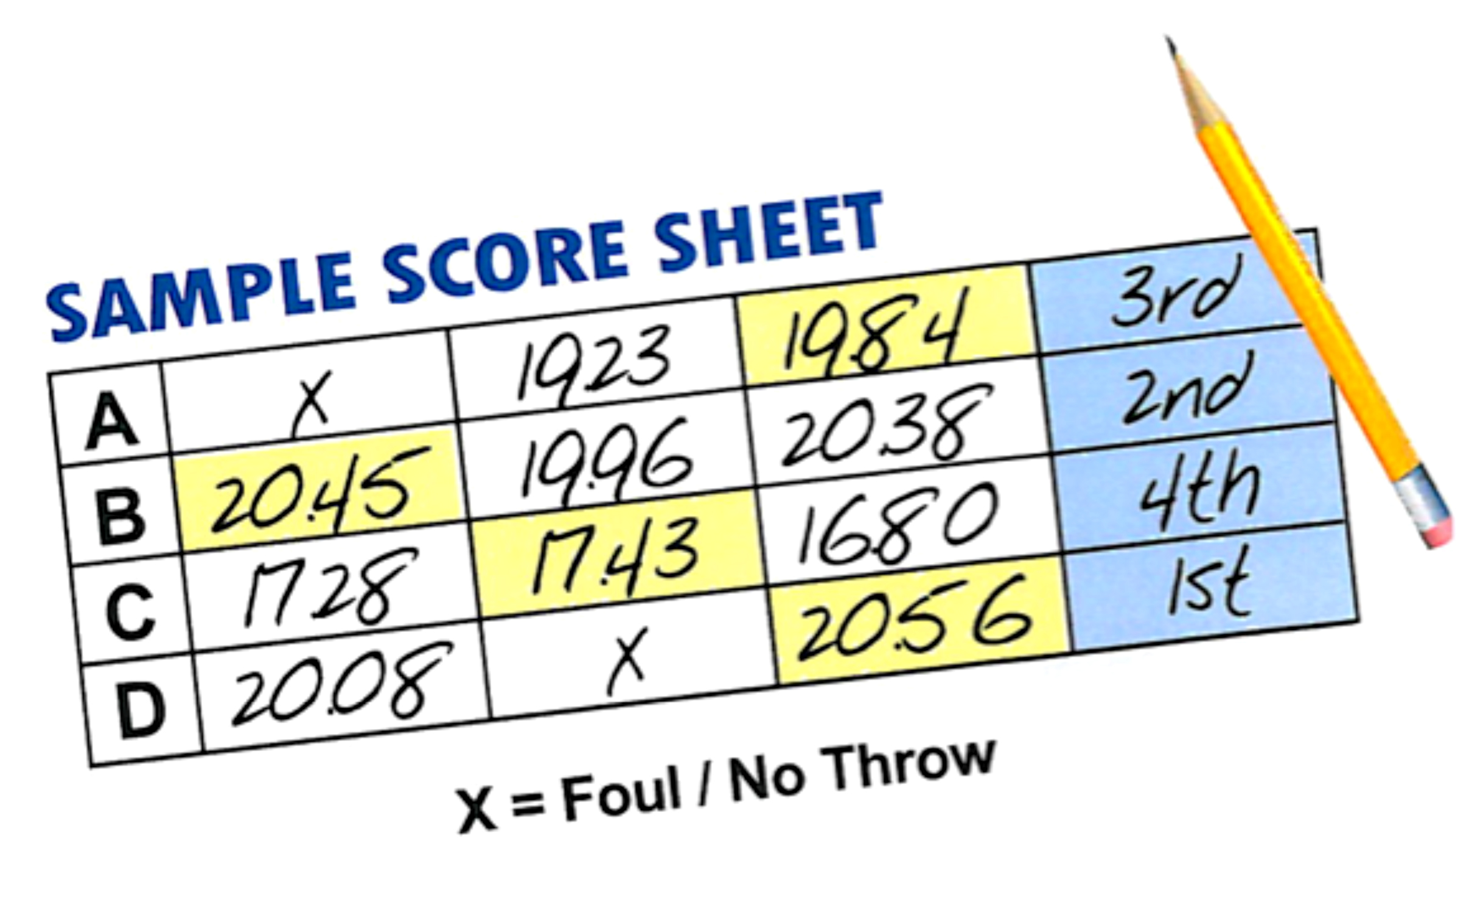
Long jump
Hints on organising the long jump
- Record competitor’s name on the result sheet.
- Allow a practice jump if time permits.
- Briefly explain the rules.
- Call competitor’s name and who will follow after them. E.g. John Smith followed by Sam Jones. This allows the event to run efficiently and without delays.
- Specify the number of jumps. (Three jumps each. The top 6 then have an extra 3 if an appropriate standard has been reached.)
Important rules
- A “no jump” is recorded as such; it is not repeated.
- Foot in front of the board at take off is a “no jump”.
- Two-foot take off is a “no jump”.
- No walking back through the pit after the jump.
- No somersaulting.
- Landing on the ground outside the pit will be a “no jump”.
- Upon landing, if you touch the ground outside the pit, behind where you have landed it will be a “no jump”.
- If it is a tie, a count back will be in place. E.g. second best jump.

Long Jump | Qualifying distance¹ | Measurement distance²
JNR boys | 4.80m | 4.20m
JNR girls | 4.20m | 3.60m
INT boys | 5.30m | 4.70m
INT girls | 4.50m | 3.80m
SNR boys | 5.60m | 4.80m
SNR girls | 4.40m | 3.80m

- Qualifying distances are distances that have to be achieved for extra jumps. If more than 6 competitors achieve this mark, only the top 6 will be awarded extra attempts.
- Measurement distances are the minimum distance that must be achieved to be measured. This will be marked out by officials.

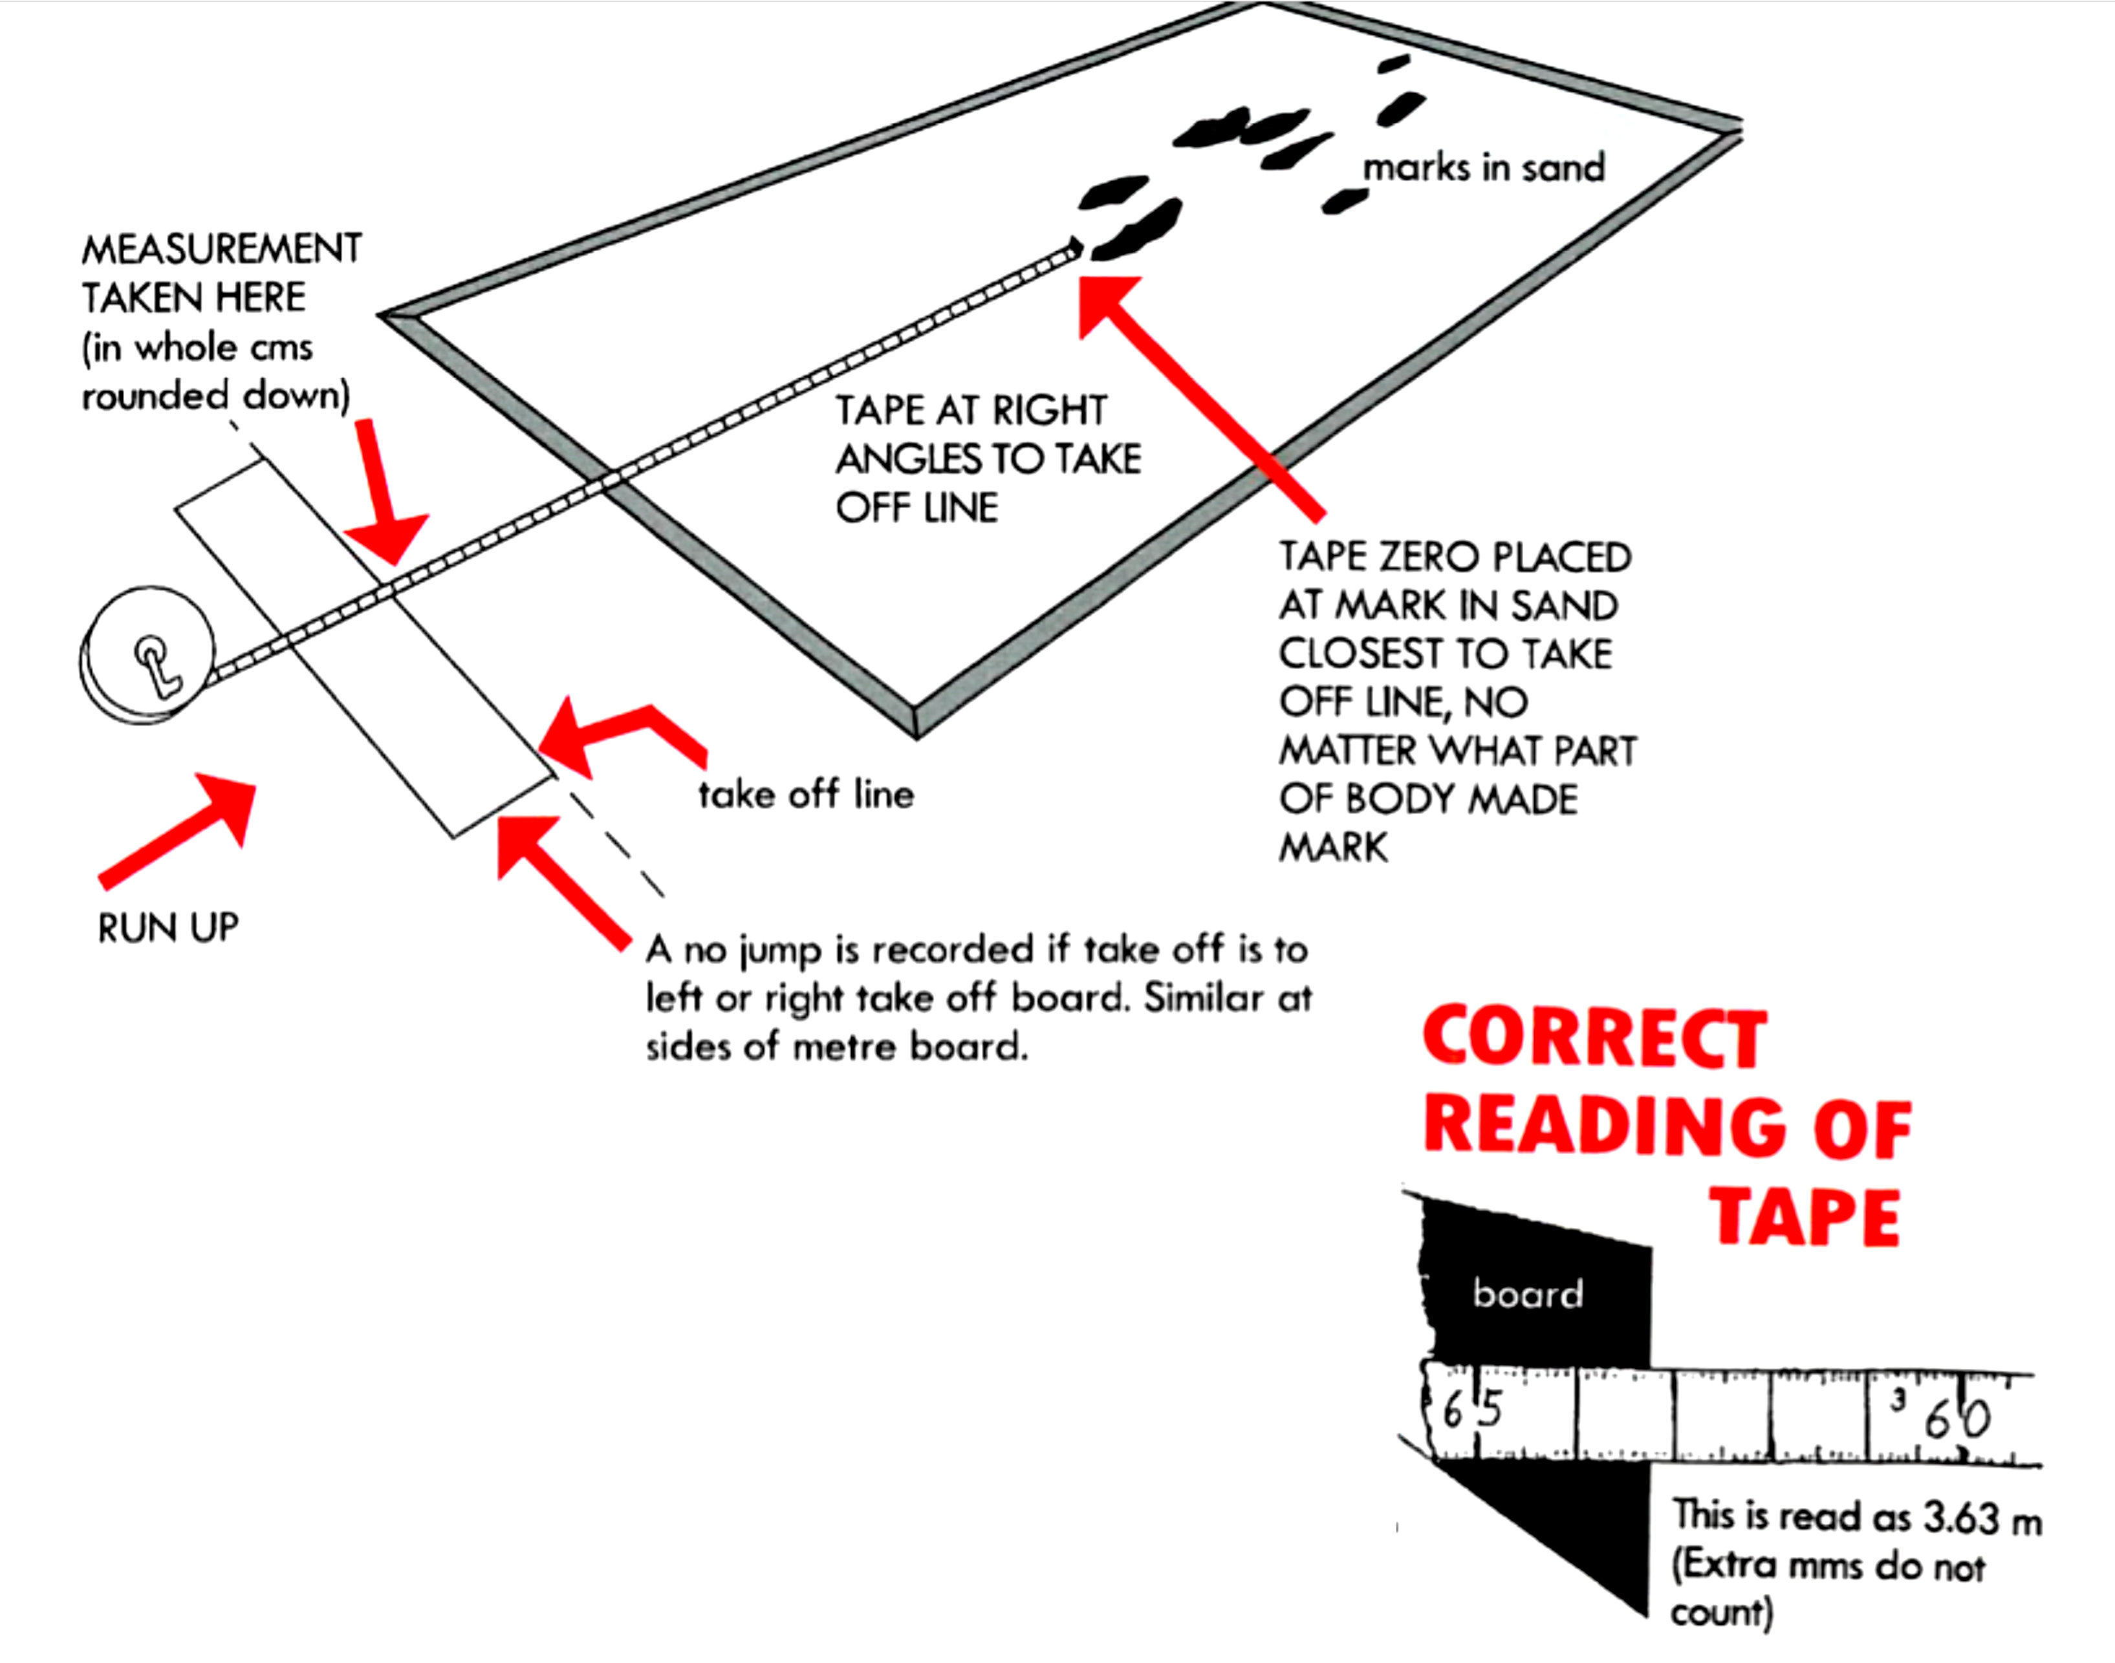

Triple Jump
Hints on organising the triple jump
- Record competitor’s name on the result sheet.
- Allow a practice jump if time permits.
- Briefly explain the rules.
- Call competitor’s name and who will follow after them. E.g. John Smith followed by Sam Jones. This allows the event to run efficiently and without delays.
- Specify the number of jumps. (Three jumps each. The top 6 then have an extra 3 if an appropriate standard has been reached.)
Important rules
- A “no jump” is recorded as such; it is not repeated.
- Foot in front of the board at take off is a “no jump”.
- Jumpers may choose what board they will take off from but must indicate so to an official.
- Correct jumps will be a hop, step, jump. In other words if you take off from your right foot, you must then land on your right (hop) then onto the left foot (step) and then “jump” off that left foot into the pit. (So, right foot off the board, right foot, left foot, land in the pit. Or the other way round, left, left, right, land.)
- Failure to make the pit is a “no jump”.
- No walking back through the pit after the jump.
- No somersaulting.
- Landing on the ground outside the pit will be a “no jump”.
- Upon landing, if you touch the ground outside the pit, behind where you have landed it is a “no jump”.
- If it is a tie, a count back will be in place. E.g. second best jump.
Triple Jump | Qualifying distance¹ | Measurement distance²
JNR boys | 10.00m | 9.20m
JNR girls | 8.70m | 7.70m
INT boys | 11.10m | 10.00m
INT girls | 9.20m | 8.00m
SNR boys | 11.50m | 10.00m
SNR girls | 9.50m | 8.00m

- Qualifying distances are distances that have to be achieved for extra jumps. If more than 6 competitors achieve this mark, only the top 6 will be awarded extra attempts.
- Measurement distances are the minimum distance that must be achieved to be measured. This will be marked out by officials.

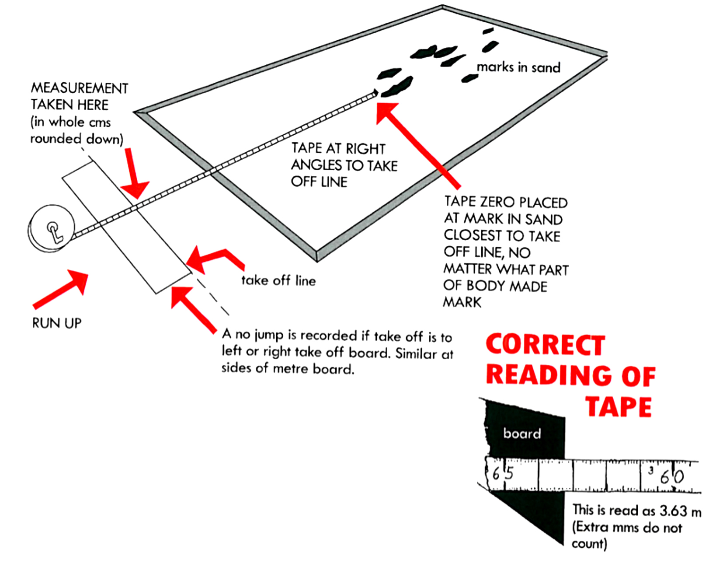

Javelin
Hints on organising the javelin
- Record competitor’s name on the result sheet.
- Allow a practice throw if time permits.
- Briefly explain the rules.
- Call competitor’s name and who will follow after them. E.g. John Smith followed by Sam Jones. This allows the event to run efficiently and without delays.
- Specify the number of throws. (Three throws each. The top 8 then have an extra 3 if an appropriate standard has been reached.)
- The distance of the throw is measured from the throwing arc to the point where the tip of the javelin landed, rounded down to the nearest centimeter.
- Safety is important. Make sure before every throw officials and competitors are watching the throw!
Important rules
- The javelin is held at the grip and thrown over the shoulder or the upper part of the throwing arm. Spinning is illegal.
- To constitute a legal throw, the javelin’s metal tip must break the ground first. It must land inside the sector. Touching the line is a “no throw”.
- If a thrower touches the arced line at the end of the runway or steps past the line it is a “no throw”.
- The thrower may not leave the throwing area (the runway) until after the implement lands.
- The javelin is not a toy. It is for throwing only!
Secondary school javelin weights
JNR girls 500g JNR boys 600g
INT girls 500g INT boys 700g
SNR girls 500g SNR boys 700g

Boys Girls
Wheelchair (AWDWC) 400g 400g
Intellectual (AWDID) 700g 500g
Cerebral Palsy (AWDCP) 600g 400g
Amputee/other (AWDAMP/other) 700g 500g
Vision Impairment (AWDVI) 700g 500g

Measuring the Javelin
- Measurement is from where the tip of the javelin first strikes the
ground to the inside edge of the runway arc.
- The zero end of the tape goes out to where the javelin lands.
- The measuring tape is pulled straight back through the 8m point on
the runway.

Javelin | Qualifying distance¹ | Measurement distance²
JNR boys | 26.00m | 21.00m
JNR girls | 15.50m | 10.00m
INT boys | 35.00m | 25.00m
INT girls | 23.00m | 16.00m
SNR boys | 40.00m | 30.00m
SNR girls | 23.00m | 18.00m

- Qualifying distances are distances that have to be achieved for extra throws. If more than 8 competitors achieve this mark, only the top 8 will be awarded extra attempts.
- Measurement distances are the minimum distance that must be achieved to be measured. This will be marked out by officials

Source: Sport Waikato

