Treatment and rehabilitation of injuries
Ensure injuries that occur during training or competition are treated immediately. Always have a first aid kit on hand and, if possible, a currently qualified sports first aider.
Medical assessment
Any moderate to severe injuries must be assessed by a qualified professional as soon as possible. Fractures and dislocations need special attention. Remove the athlete from the playing area, unless there is a risk that movement may cause further injury.
If a neck or spinal injury is involved, do not move the injured athlete until professional help arrives. All head injuries are serious, possibly life threatening, if not followed up. Concussion can require a three-week stand-down from all sporting activity, dependent upon the length of unconsciousness and memory loss.
Progressive stages of rehabilitation
Bringing athletes back to full fitness is a gradual and progressive process that needs to be undertaken with patience and care. If, at any stage, athletes feel pain, rather than just a mild discomfort, they should immediately revert to the previous stage of rehabilitation.
Rehabilitation programmes and stand-down periods are recommended on the basis of the medical assessments made after the injury. It is important that they are adhered to. Coaches need to be aware of ‘athlete bravado’. Many athletes are reluctant to cut down their training, and strongly resist enforced rest.
Coaches can help them by:
- stressing the importance of rest to recovery
- encouraging patience with their injuries and the rehabilitation process
- emphasising that a return to full training and competition too soon could cause more damage, putting them further behind rather than progressing forward.
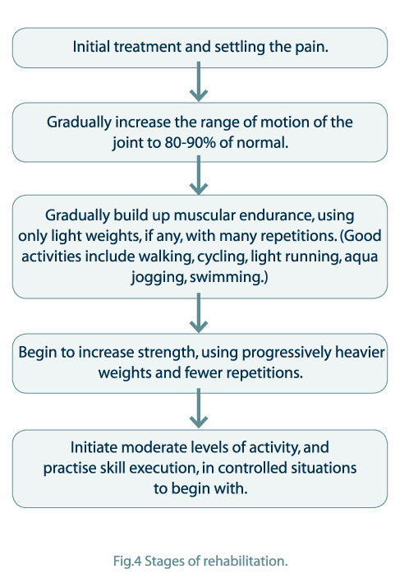

As a sport coordinator or coach, you must be satisfied that injured athletes are completely recovered before they return to full training and competition. You should follow the guidelines below when determining whether athletes have recovered sufficiently to participate fully in all activity. Ask the athletes if they:
- have regained full strength
- have regained full range of movement
- have no pain or inflammation
- are able to perform all of the skills required in the sport, and
- are psychologically prepared before returning to competition.

If you are in doubt about an athlete’s return to sport, consult the athlete’s medical specialist to ensure that correct rehabilitation has been undertaken. Once athletes return to training and competition, it is important that you ensure that they prepare properly for activity, with an adequate warm-up at the beginning of all sessions, and a cool-down at the end. You should also monitor the athletes’ performances and watch for any signs of difficulty.

