Science in Coaching

Resource: Biomechanical Principles

In addition to this resource, coaches should also read Coaching New Zealand Principles of Coaching Level 1, pp 51-57 to help complete Learning Outcome 3.

Coaches aim to assist their athletes to improve their sporting competency and so achieve their performance goals. As a contribution to achieving these outcomes, coaches require sport specific knowledge and an understanding of biomechanical principles relevant to sports performance. Hay has defined biomechanics as “the science concerned with the internal and external forces acting on a human body and the effects produced by these forces.” (Hay 1993, p.2). The following is a summary of biomechanical principles involved in sports skills.

1. Apply forces in the direction you want an object to travel.

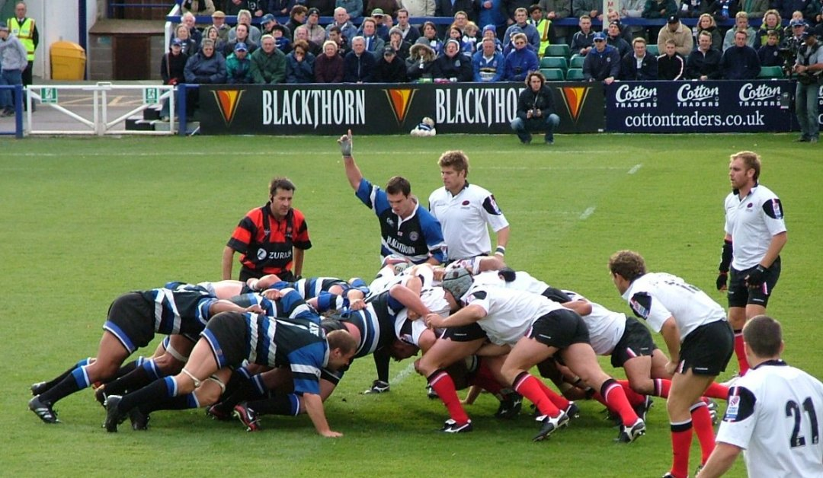

2. Position body to effectively produce ground reaction force. [action-reaction]

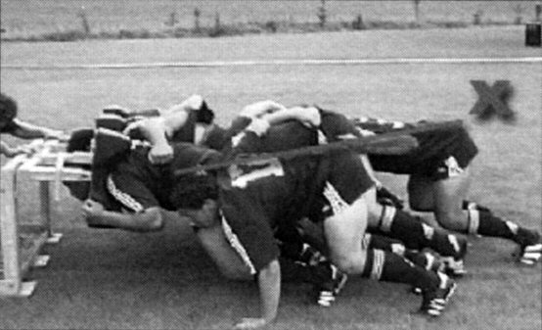
3. Generate necessary ground reaction forces by using large muscle groups.

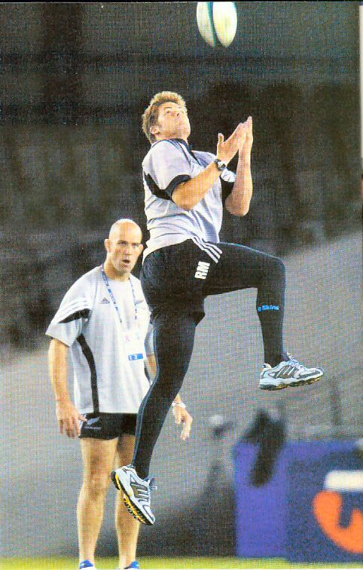

4. Use appropriate combination of force and timing to produce desired change in motion.

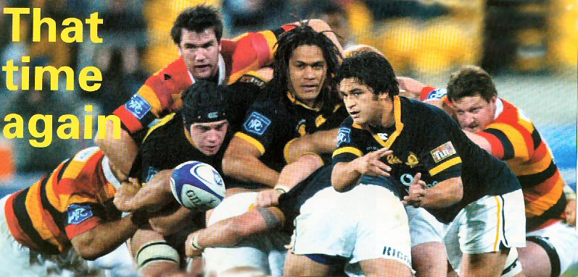

5. Reduce impact forces by maximising the time taken to change the motion.

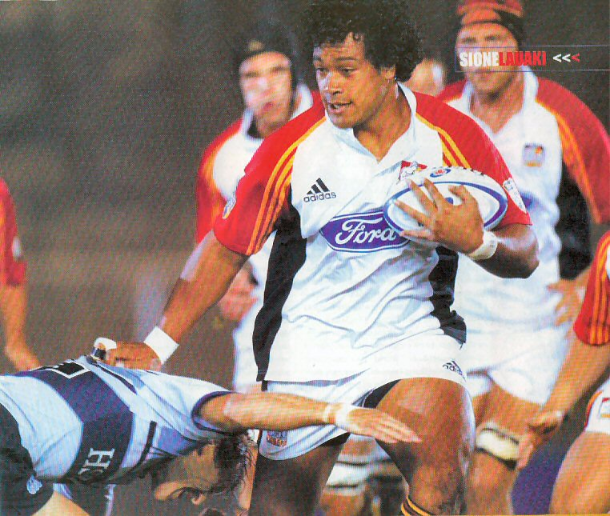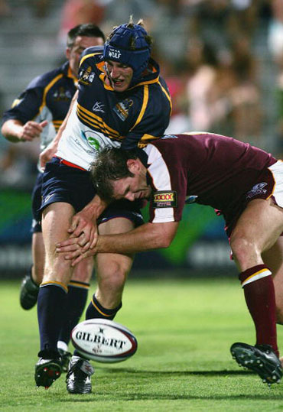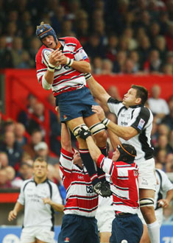

6. In activities involving projecting the human body or other objects, use a large number of joints in sequence from large to small. [segment sequencing]

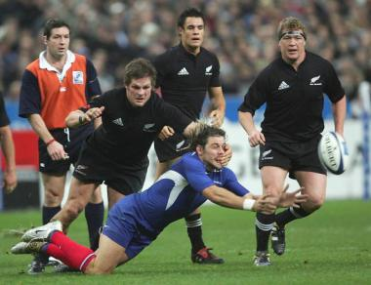

7. Select appropriate velocity of release, angle of release and height of release to produce the desired result.

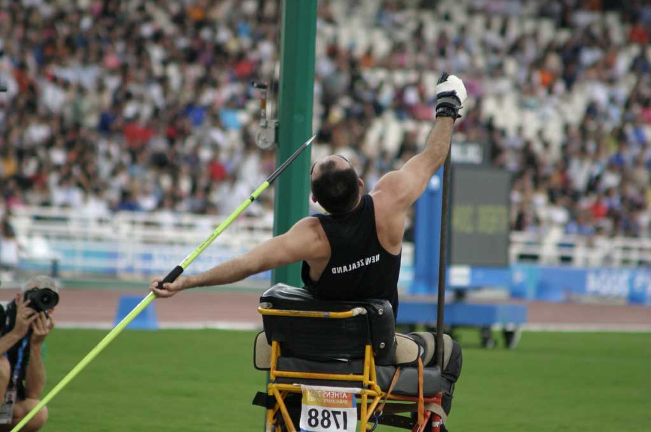

In activities in which the human body is projected, performance may be enhanced by redistributing the mass of the body about the centre of gravity.

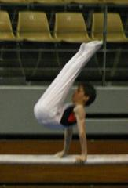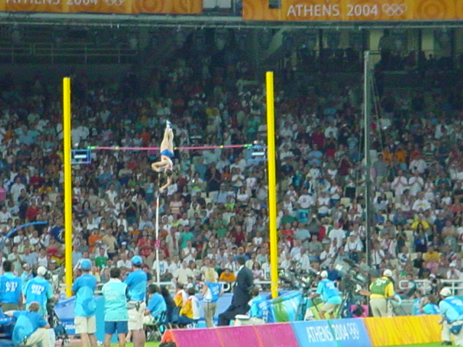

9. Stability is increased by increasing the area of the base of support, moving the centre of gravity towards an expected perturbing force and lowering the centre of gravity.

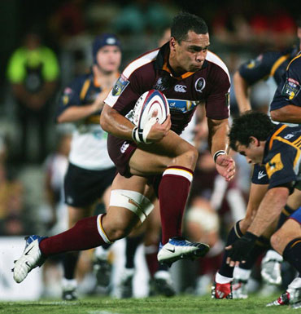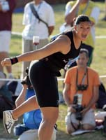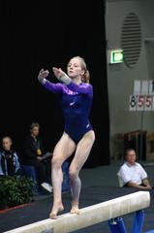

10. To produce rotation, apply the force away from the axis of rotation.

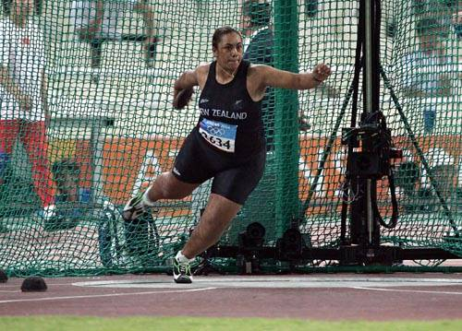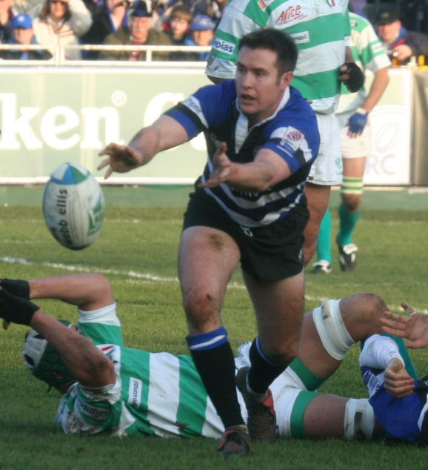

11. Increase the rate of rotation by redistributing the mass of the body close to the axis of rotation.

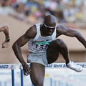

12. Optimise release velocity of an object by a suitable combination of rate of rotation and distance of the object from the axis of rotation.

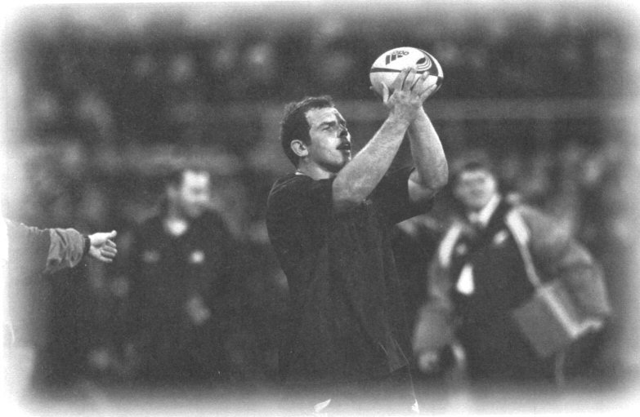

Summary
It is important to develop the ability to observe human movement in a sports context in a systematic way and understand that there are different phases within any given movement. Within each phase of a specific movement, there are key components of the movement and specific biomechanical principles that apply. It is important that a coach has the ability to analyse movement using these principles. Of equal importance is what the coach decides to do with the knowledge acquired from such an analysis. The modern approach to coaching encourages athletes to perform skills in a way that suits them as individuals. Coaches should encourage athletes to arrive at their own movement solutions as far is possible without allowing the athlete to be compromised in terms of safety at any stage. The coach should therefore not overload the athlete with excessive technical information. Information derived from the analysis of movement might provide key insights for well phrased questions that the coach will put to the athlete. This information can be vital in assisting the athlete towards the level of movement proficiency that the athlete is striving for.

Middle Childhood Coaching Communities
Middle Childhood athletes will often be involved in game situations involving large muscle groups engaged in fundamental movements. While coaches will still profit from being able to engage in a biomechanical analysis of this movement, their use of such information and the feedback that they offer that age group will be somewhat different from a coach working with competitive adults.

The message here is that athletes at all levels will profit from the ability of the coach to analyse movement appropriately. A second part of the message is that coaches will differ slightly in terms of the way they use the information derived from their ability to analyse movement, especially in terms of the feedback that they give to athletes. This feedback is discussed and practised in the effective coaching module that explains coaching feedback in some detail, especially as it relates to an athlete centred coaching philosophy.

Reference
Hay, J.G. (1993). The biomechanics of sports techniques (4th Ed). Englewood Cliffs, NJ: Prentice Hall.

