Science in Coaching

Resource: Anthropometry for Coaches (Competitive Adult Coaching Community)

This resource is needed to complete Learning Outcome 6 for the Competitive Adult Coaching Communities ONLY.

Anthropometry is a branch of anthropology and is concerned with the measurement of the human body. While a variety of different sciences apply the principles of anthropometry, from nutritionists concerned with obesity to ergonomists concerned with low back pain, anthropometry has long been applied in a sporting setting due to the influence body morphology and somatotype has on sporting performance.

The value of being able to assess an individual competitive adult athlete’s somatotype and therefore their morphology is that it allows a coach to ensure that not only are the athlete’s strengths being optimised, but also, allowances (where possible) can be made for weaknesses. Where improved performance is the key, these weaknesses may have the potential to be altered with adapted training, or the athlete’s role changed so that the weakness may become a strength. While somatotype and morphology are both sciences concerned with the structure of a person, the term somatotype is generally used when rating an individual’s structure, while the term morphology is used when trying to describe an individual’s physique. Therefore somatotype ratings are more concerned with an individual’s current physique where as morphology is more the adaptability of the various components of somatotype over time.

Somatotyping

The idea of somatotyping is to describe body shape and composition that allows for both a quantitative and a qualitative summary of an individual physique. The outcome is a three number rating which describes an individual’s endomorphic, mesomorphic and ectomorphic tendency. Endomorphy relates to the relative fatness, mesomorphic the relative musculoskeletal (muscular and skeletal) robustness and ectomorphy the relative linearity or slenderness of the individuals physique. As the ratings are made relative to the individual’s stature, the somatotype rating is made independent of stature. The following image helps to illustrate the three categories of somatotype.

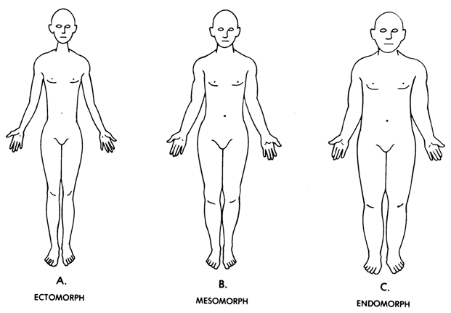

Image from: http://www.medtrng.com/anatomy%20lesson/bhp2_files/image002.gif

A score for the three somatotype ratings are always reported endomorphy, mesomorphy then ectomorphy, with a rating usually on a scale of 1 – 12. While values in theory can be outside these ranges they are extremely rare, with most individuals falling between a rating of 1 ½ and 7 for each of the categories.

The following shows how the values for each of the ratings are applied to the morphology of the individual using descriptive cues for each of the ratings.

Endomorphy
Rating | Description
1 – 2 ½ | Low relative fatness; little subcutaneous fat; muscle and bone outlines visible
3 – 5 | Moderate relative fatness; subcutaneous fat covers muscle and bone outlines; softer appearance
5 ½ – 7 | High relative fatness; thick subcutaneous fat; roundness of trunk and limbs; increased storage of fat in the abdomen
7 ½ - 8 ½ | Extremely high relative fatness; very thick subcutaneous fat and high amounts of abdominal trunk fat; proximal concentration of fat in limbs

Mesomorphy
Rating | Description
1 – 2 ½ | Low relative musculoskeletal development; narrow skeletal diameters; narrow muscle diameters; small joints in limbs
3 – 5 | Moderate relative musculoskeletal development; increased muscle bulk and thicker bones and joints
5 ½ – 7 | High relative musculoskeletal development; wide skeletal diameters; bulky muscles; large joints
7 ½ - 8 ½ | Extremely high relative musculoskeletal development; very bulky muscles; very wide skeleton and joints

Ectomorphy
Rating | Description
1 – 2 ½ | Low relative linearity; great bulk per unit of height round like a ball; relatively bulky limbs
3 – 5 | Moderate relative linearity; less bulk per unit of height; more stretched out
5 ½ – 7 | High relative linearity; little bulk per unit of height
7 ½ - 8 ½ | Extremely high relative linearity; very stretched-out; narrow like a pencil; minimal bulk per unit of height.

Adapted from: Norton, K. & Olds, T. (2004). Antrompometrica. Sydney, AUS: UNSW Press.

While in a scientific setting, exact measures of bodyfat, stature, mass, girths and bone breadths allow for calculation of an individuals somatotype (for more details of this see Norton & Olds, 2004, pp. 149-156), visual somatotyping can be a quick and effective method to assess differences in athletes morphology and in particular changes over time in athlete morphology.

The Visual Somatotype (Somatotype Photography)

The visual somatotype method generally involves taking standardised photographs of the athlete and rating their endomorphic, mesomorphic and ectomorphic tendencies based on the visual descriptions give above. The athlete is normally viewed from standardised, side and rear views while dressed in minimal clothing. Minimal clothing means wearing such items as bathing suits, bike pants and other tight fitting clothing that allow the size and contours of the body to be seen.

As an example, the following image shows the standardised positions used for somatotype photography. In this case the individual is a male with a calculated somatotype of 1 ½ - 6 ½ - 2 ½. Therefore the individual is considered to be high in terms of muscle mass and skeletal size, but rates low in terms of fatness, slenderness and linearity, which can be easily seen from the photographs.

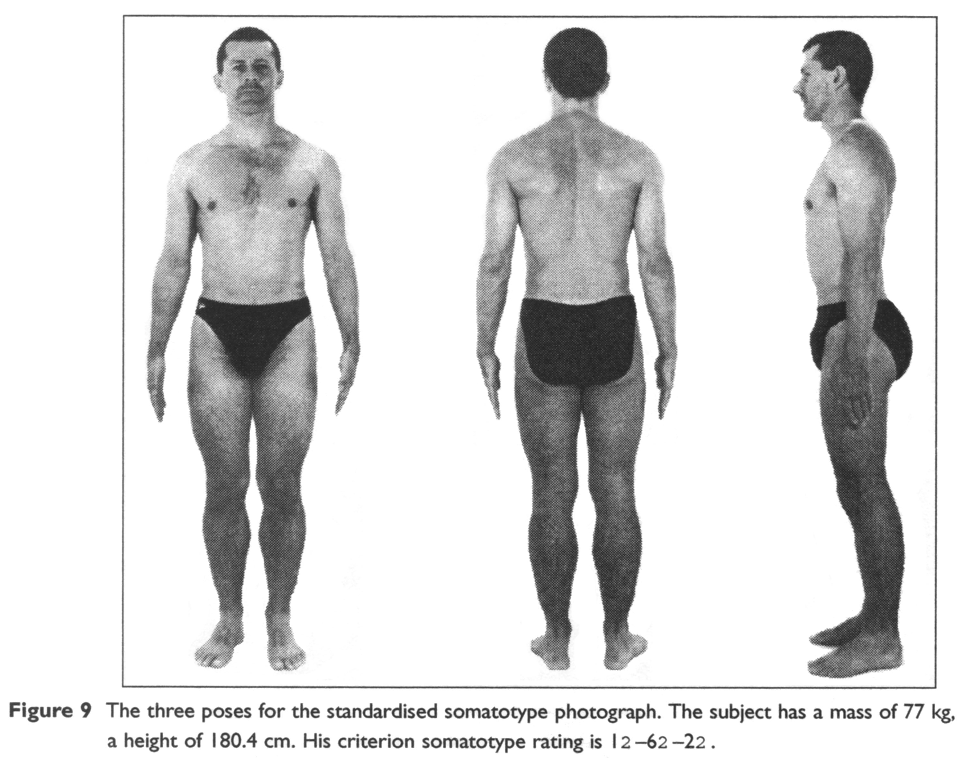
From: Norton, K. & Olds, T. (2004). Antrompometrica. Sydney, AUS: UNSW Press.

Sporting Applications of Somatotype

It has long been known that an athlete’s anthropometric characteristics can play a major role in their sporting success. This has brought about the idea of ‘morphological optimisation’ which is the theory that only those athletes that have the ideal body type for their chosen sport will remain competitive at higher levels. While it is obvious that in some sports skill and physical fitness may also be key contributing factors this hasn’t stopped anthropometric profiling being used in a number of sports. For example, an individual who scores low on mesomorphy and high on ectomorphy is unlikely, despite skill and fitness, to ever compete at a high level in rugby. An individual with high endomorphy rating and moderate mesomorphy ratings is unlikely to ever be highly competitive in ultra-endurance sport. This doesn’t mean that only individuals with the optimal morphology will be competitive, it is just that the majority of successful athletes will be of that morphology. It also doesn’t mean that only individuals with the optimal morphology for a sport can participate in that sport.

While this may seem obvious at the elite sporting level, morphology and anthropometry still has applications to the amateur athlete, child sports participant or competitive adult. From an injury perspective some athletes may be more prone to injury if their morphology does not match the demands of their sport or their position within a team. For some athletes, learning complex tasks may be made difficult as biomechanically they are disadvantaged due to their morphology. Within sporting teams, particular players may be better suited to certain positions based on the physical demands of that role and the athlete’s physique. For the coach of children, ensuring that physical differences between athletes is considered during both training and games can help to not only reduce injuries, but also allow for success for those participants who may not be physically the best suited to that sport or at a different developmental stage to the other athletes.

Anthropometry and Body Image

The term ‘body image’ is a broad term describing an individual’s internal and subjective representation of their physical appearance and bodily experience. Body image includes the perceptual, cognitive and affective elements where perceptual relates to visuospatial and sensory judgements; cognitive relates to thought processes and thinking styles; and affective refers to individual emotions and attitudes. The analysis of body image therefore considers both an individual’s perceptions of his or her body, and the same individual’s perceptions of the bodies of others.

Anthropometry is linked closely with body image as anthropometry provides a quantitative value to an individual’s body size and shape, while body image provides the qualitative measure. Numerous studies have been done showing that age, gender, education, genetics and mass media can all influence an individual’s body image both positively and negatively.

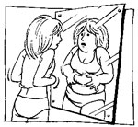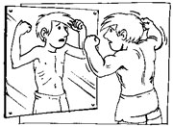

In a sporting setting, the desire to conform to a particular sports’ perceived ideal body shape has been linked to eating disorders, unsafe training methods and the abuse of steroids. The uniforms, particularly of female athletes, and the portrayal of high profile individuals in the media, have also been linked to teenagers dropping out of sport due to the pressure to confirm to a particular image. As a result of these pressures, there is a great need to be sensitive and aware of the influence body image can have on an individual’s motivation and goal setting.

Other resources have more information relating to body image. While many articles are scientific in nature, they will highlight the consequences of distorted body image.

References

Norton, K. & Olds, T. (2004). Antropometrica. Sydney: UNSW Press.

http://www.medtrng.com/anatomy%20lesson/bhp2_files/image002.gif

